
K&M Tire

Accounts Payable SOP
10/30/2025

Table of Contents
1. K&M Tire 1
2. Office Manual Introduction 4
3. Overview 5
3.1 Conventions 5
3.2 Cautions & Warnings 5
4. Sort Mail and Paperwork 6
4.1 Invoice Sorting/Posting Guide 6
4.1.1 Freight Bills 6
4.1.2 Issuing New Credit Cards to Employees 9
4.1.3 Mighty Tire Billing 11
4.1.4 Utility and Monthly Invoices 12
4.1.5 Receiving Tray – Packer Box 13
4.1.6 Expense Reports/Check Requests 14
4.2 Electronic Invoices 17
4.2.1 A/P Email Inbox – Invoices 17
4.2.2 Verizon 18
4.3 Receivers 20
4.3.1 Printing and Matching Receivers 20
4.3.2 RGA / Mistags 25
4.3.3 Over/Shorts 26
4.3.4 Filing Incoming Invoices-Receiving 43
4.3.5 A/P Email Inbox-Receiving 44
4.3.6 A/P Entry-Receiving 46
4.3.7 Invoice/Receiver Variances 49
4.4 Processing Payments and Credits 50
4.4.1 New Vendor Setup 50
4.4.2 Setting up a Vendor for ACH Payment through MaddenCo 52
4.4.3 A/P Miscellaneous Invoice Approval 53
4.4.4 Entering AP Invoices 56
4.4.5 Recurring Entries 58
4.4.6 Mickey Thompson Anticipation 59
4.4.7 Falken Anticipation 60
4.4.8 Voiding Invoices or Checks- 61
4.4.9 United Way 62
4.4.10 Donations 63
4.4.11 Membership Requests 64
4.4.12 Funds 65
4.5 Balance and Pay by Statement 66
4.5.1 Goodyear 66
4.5.2 Firestone 69
4.5.3 Continental 70
4.5.4 Statement Verification 71
4.6 Payments 73
4.6.1 Setting up a Vendor ACH Payment through MaddenCo 73
4.6.2 Check Run 74
4.6.3 Check Run Exceptions List 76
4.6.4 Check Run – Employee Mail List 77
4.6.5 Check Run Timeframes 77
4.6.6 File Paid Invoices 80
4.6.7 Michelin Payment 80
4.6.8 Yokohama 83
4.6.9 First Financial Online Payment 84
4.6.10 BKT & Speedway Wire Transfers 85
4.6.11 Manual Blank Check 86
4.6.12 Initiate ACH-Wire Payment through Wells Fargo 87
4.7 Month End Processes 89
4.7.1 Balancing GL 1310 89
4.7.2 Balancing GL 2320 90
4.8 Year End Processes 95
4.8.1 Fiscal Year-end 95
4.9 Other 96
4.9.1 MaddenCo AP Update 96
4.9.2 Vendor History Lookup 96
4.9.3 Creating Journal Entry in General Ledger 96
4.9.4 General Ledger Re-Class (Moves) 97
4.9.5 AP Invoice Number Inquiry 100
4.9.6 Lookup Invoices using check number 102
4.9.7 Cardholder List Audit & First Financial eZ Card Access 102
4.9.8 Credit Applications for Vendors 105
4.9.9 Weekly Inventory Invoice-Receiver Check 105
4.9.10 AP Document Retention 105
4.10 Company Expense Process 108
4.10.1 Concur – Company Paid Credit Cards 108
4.10.2 Concur – Cash Reimbursement 110
4.10.3 Concur – Hide/Unhide Transactions 113
4.11 Company Credit Card Audit 114
4.11.1 Create Credit Card Audit List 114
4.11.2 Company Credit Card Audit 114
4.12 Warehouse/ROM/Sales Funds Audit Process 116
4.13 Mighty Tire Billing 117
4.14 External CAM Reconciliations 118
5. Conclusion 121
Appendix A: Miscellaneous 122
Appendix B: Supportive Department Summaries 123
Appendix C: Glossary 124
Appendix D: Referenced Documents 125
Appendix E: Approvals 127
Appendix H: Revision History Tracking 128

List of Figures
No table of figures entries found.

List of Tables
Table 1 - Support Points of Contact Error! Bookmark not defined.
Table 2 - Acronyms 80
Table 3 - Glossary 81
Table 4 - Referenced Documents 82
Table 5 - Approvals 83
Table 6 - Revision History Tracking 84

K&M Tire
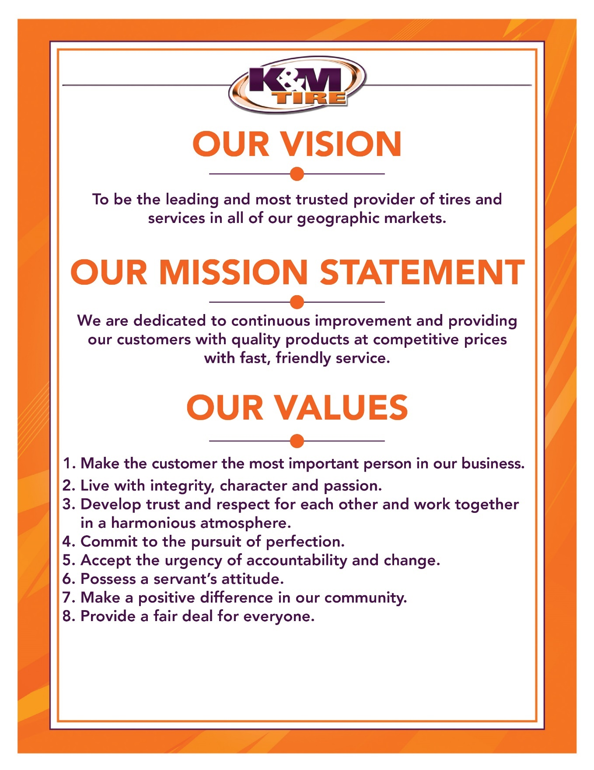



K&M Tire US Footprint
http://kmtire.com/km-cgi/distmap

Office Manual Introduction
This manual is intended to aide in the training of the K&M Tire Accounts Payable team by providing step by step detail of the processes.

Provide link & path of where to find up-to-date version

ADD PRIVACY AND/OR SECURITY CONSIDERATIONS HERE.

Overview

Conventions
This document provides screen prints and corresponding narrative to describe how to use the Maddenco, WISE and K&M Intranet, known as “company systems”
When an action is required on the part of the reader, it is indicated by a line beginning with the word “Action:” For example:
Action: Click on OK.
Fields or buttons to be acted upon are indicated in bold italics in the Action statement; links to be acted upon are indicated as links in underlined blue text in the Action statement.
Note: The term ‘user’ is used throughout this document to refer to a person who requires and/or has acquired access to the company systems.

Cautions & Warnings
This manual does not supersede any safety or company policy.

Sort Mail and Paperwork
Overview: This section of the procedure covers mail, paperwork, and emails that come from both internal and external customers. As we continue to go paperless, we mostly receive emails for all check requests and invoices that need paid. Sorting mail, paperwork, and working through emails is the ‘start’ of our processes. Once these items are received and thoroughly reviewed by AP department, they are then sent off for approval before being entered into Madden Co for payment.

Invoice Sorting/Posting Guide
This guide below directs you on how to sort, deliver and post the incoming invoices. These invoices will arrive by email, mail and/or transfer bags. Click here.

Freight Bills
This procedure shows the steps on how post charges to UPS and FedEx.

- UPS (Receive from Logistics)
  - Starting on page 3 of each invoice, match ‘Pickup Record’ (if applicable) and Tracking Numbers to the receipts filed in the drawer
    - Folder ‘UPS & FedEx Receipts’
  - Review each charge keeping an eye out for Adjustments for audit fees
    - If Adjustments or audit fees are present, it should be $1 per listed tracking number and is the result of not Entering dimensions at the time of creating the label.
    - Ensure each Tracking Number was charged to the correct account, if not, the Sender will show a different warehouse
    - If billed third party, about will be 0, therefore it will not need coded
    - Code approved ‘UPS WorldShip’ and ‘Adjustments & Other Charges’ to 3920-location
      - Sometimes charges will need coded to other locations
  - Return to page 1 and review the Summary of Charges and code accordingly
    - Sioux Falls / Tea
      - Half service charge to 3950-1-2
      - Remainder to 3920-48
    - Carter Lake / Omaha – daily pickup
      - 3920-55
    - Park City / Wichita – daily pickup
      - 3920-57
    - St Paul
      - Half service charge to 3950-1-2
      - Remainder to 3920-51
    - Delphos
      - Half service charge to 3950-1-2
      - Remainder service charge to 3920-1
    - Merrimack
      - Service charge is coded to 3950-1-2
    - Grinnell
      - Service charge to 3950-1-2
  - If we are mailing titles code to warehouse it is shipping to
  - If Warehouse Manager is shipping items, code to 3920-58
  - If charge needs passed to employee, code to 1580-1 and give to supervisor to bill
- Track invoice number, date, and amount on correct tab (match account number)
  - F: Accounts Payable/Shared/Weekly Freight Bills
  - Save and close
- If coded to 3950-1-2 track on A/R spreadsheet. Ensure you are on tab GL 3950-1-2 (Current Year). Leave a few blank cell rows.
  - F: Accounts Receivable/Shared/Amazon/Amazon Open Items

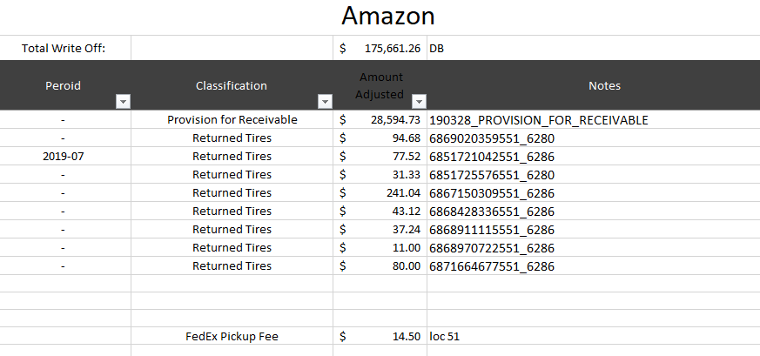
    - Save and close
  - Enter invoice into MaddenCo by following the A/P Entry Procedure, using vendor # 868

- FedEx Ground (Mail)
  - Starting on page 2 of the invoice, match ‘Tracking Number’ to the receipts filed in the drawer
    - Folder ‘UPS & FedEx Receipts’, if none, continue to next step
  - Review charges to get a good understanding of what the charges are for
    - If service charge only, continue to step 4c
    - If more than service charge and the sender is Walmart/Jet, look at detailed charge, under PO#, if it says ‘NDOC P/U – Auto Comm’ for each charge code to 3950-1-2
    - If more than service charge and the sender is Walmart/Jet, look at detailed charge, under PO#, if it says ‘Address Correction’ for each charge, do not pay, give copy to Operations Support Specialist to contact FedEx rep. Pay service charge and other qualifying items, if applicable as normal, make copy of invoice and note that Operations Support Specialist is looking into ‘Address Correction’ item and follow up as needed until resolved
    - If more than service charge and the sender is Amazon, make copy of invoice and give to Operations Support Specialist (let Operations Support Specialist know to code to below)
      - Code Amazon items to 3920-47
    - If charge needs passed to employee, code to 1580-1 and give to supervisor to bill
    - If charge says the Sender or Recipient is Director of Marketing, send to Director of Marketing for confirmation (probably code to 4085-1-210)
    - If no ‘hits’ send to logistics
  - Track invoice number, date, and amount on correct tab (match account number) – do not need to track account number 3044-1185-6
    - F: Accounts Payable/Shared/Weekly Freight Bills
      - Code to 3950-1-2 if service charge for an amazon location (1,51,84,42,43,24)
    - Save and close
  - If coded to 3950-1-2 track on A/R spreadsheet.
    - F: Accounts Receivable/Shared/Amazon/Amazon Open Items
  - Ensure you are on tab GL 3950-1-2 (Current Year). Leave a few blank cell rows.
    - ‘Classification’ is FedEx Pickup Fee
    - ‘Amount Adjusted’ is amount of invoice
    - ‘Notes’ is the location of the charge ex. Loc 51


    - Save and close
  - Enter invoice into MaddenCo by following the A/P Entry Procedure

- FedEx Freight (mail)
  - Review charges to get a good understanding of what the charges are for. (K&M should not be receiving charges from FedEx Freight)
    - If charge is related to Walmart shipping a return to K&M code to 3950-1-3
    - If charge needs passed to employee, code to 1580-1 and give to supervisor to bill
  - If coded to 3950-1-3 track on A/R spreadsheet.
    - F: Accounts Receivable/Shared/Walmart/Walmart Open Items
  - Ensure you are on tab GL 3950-1-3 (Current Year). Leave a few blank cell rows.
    - ‘Classification’ is Freight
    - ‘Amount Adjusted’ is amount of invoice
    - ‘Notes’ is FedEx Freight inv #

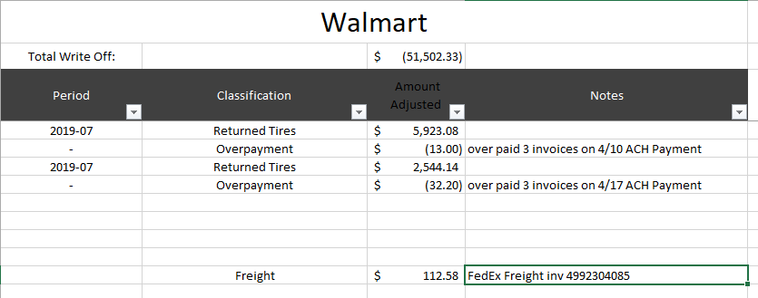
    - Save and close
  - Enter invoice into MaddenCo by following the A/P Entry Procedure, using vendor #2886

Issuing New Credit Cards to Employees
This section outlines the procedure for handling new corporate cardholder requests, such as those for new or existing employees within K & M needing a Business Credit Card.
- Employee’s Manager:
- When a new or existing employee needs a Business Credit Card, the employee’s manager will submit the request to their department’s ELT member using the Credit Card Request Form (see Appendix D: Referenced Documents) F:\Accounts Payable\Public\Concur & Company Credit Cards which includes the following details.
    - Employee Name – First/Last legal name
    - K&M Email
    - Mobile Phone
    - Work Phone
- The employee’s manager should document any special requests, such as deviations from the standard credit limit, and specify the names of Approver #1 and Approver #2 for Concur. Approver #1 must be the cardholder’s manager, while Approver #2 should be the manager of Approver #1.
- After completing this, the manager should sign the document and forward it to the department’s ELT member for review.
If the department ELT member agrees with and approves of the request, the ELT member will sign and forward the request to the Accounts Payable Manager.
- Review by Accounts Payable Team Lead or Manager:
- The AP Team Lead or Manager will review the card request and process the new credit card request.
- If more information is required, the AP TL or Manager may contact the requester for clarification.
- The AP TL or Manager will then notify the requesting manager and ELT member when the card request is ordered.

- Issuing the Business Credit Card & Communication to the Employee:
- The AP Team Lead or Manager will set up the new credit card and Concur account for expense reporting.
  - Credit Limits are based on department
      - Operations = $5,000 per month
      - Sales = $2,500 per month.
      - Other = $2,500 unless requested & approved by manager as a higher limit
      - Anything over $10,000 needs approved by the EVP or President.
  - All temporary or permanent increases need to be sent to the AP Manager.
Temporary increases can be made immediately, and the cardholder’s manager will be notified via email.
      - Permanent increases need to be approved by the cardholder’s manager prior to the increase being entered into First Financial.

- The AP TL or Manager will email the employee with the Concur information and include the following items:
  - Welcome email including Concur Expense Log in Information including link, User ID, and Temporary Password
  - Credit Card & Expense Reimbursement Policy - to be signed by the employee and returned to the AP Department Inbox at AccountsPayable@kmtire.com
  - Direct Deposit Authorization Form – to be completed by the employee and returned to the AP Department Inbox at AccountsPayable@kmtire.com
  - Expense Guide provided by Concur
  - EZ Card Enrollment Guide provided by First Financial Bank.
- The AP TL or Manager will add the employee to the Concur/Credit Card audit schedule for 90 days (3 full calendar months) from issuing date of the new card.
  - example: Card issued on August 29th will be added for December audit.
- The card will be mailed to the K & M Tire Corporate address in Delphos, Ohio. The Administration team will then contact the employee, letting them know their card is here and ask them where the card needs to be sent.
  - The card will then be shipped to the employee via UPS or FedEx to the location the employee requested.
  - The PIN number envelope (thin envelope automatically printed by the issuing bank) is not sent to the employee and will be shredded by the Admin Team.

- Responsibilities:
- The employee’s manager is responsible for submitting the request to the department ELT member for approval.
- The department ELT member is responsible for approving and forwarding the request to the Accounts Payable Manager for review.
- The AP Team Lead or Manager is responsible for processing the request for the new Corporate Business Card, setting up the card and Concur Expense Account, adding them to the annual Concur/Credit Card Audit schedule and emailing the employee the follow up documents as referenced above.
- The Admin Team will verify that the signed Company Credit Card & Expense Reimbursement has been received prior to shipping the card to the employee. They will shred the PIN envelope.

Mighty Tire Billing
Mighty Tire invoices and credits must only be paid by Tribune Trucking. This procedure explains the process on how to take a Mighty Tire invoices/credits and create an excel invoice that will be paid by K&M to Tribune Trucking. Tribune Trucking will then pay Mighty Tire once funds are received.
- Receive Mighty Tire Invoices
- Invoices will be provided by the Accounts Payable Department
- Create Excel Invoice
- Navigate to F: Accounting/Shared/Bank Ledgers/Tribune Trucking/Invoices/Mighty Tire Billing/Invoices
- Update the 'Date' to current date
- Update 'Invoice Number' to the next numerical number
- Under 'Description' list each invoice number separately that was provided
  - If a credit, update the 'Quantity' column to negative 1 (-1)
- Update 'Price' for each invoice
- Review accuracy and ensure the 'Total' formula is calculating correctly
- Verify Accuracy between Excel Invoice and Mighty Tire Invoice
- Add up the totals for the Mighty Tire invoices and confirm it matches the excel invoice created in step 5.4.2.
- Save Spreadsheet in step 5.4.2.
- Print Excel invoice to PDF and save on Desktop
- Distribute Invoice(s)
- Send printed invoice (step 5.4.5.) to Accounts Payable Department
  - Accounts Payable Department will process invoice for payment to Tribune Trucking.

- Send printed invoice (Step 5.4.5) and Mighty Tire invoice copies to Samantha Bowersock
  - Sam will wait for funds to be received by K&M before processing payment from Tribune Trucking to Mighty Tire (Ziegler)

Utility and Monthly Invoices
Once a month AP pays utilities and monthly expenses, this procedure displays the steps to ensure each utility is accurately billed.

- Search account number on utilities spreadsheet
  - F:\Accounts Payable\Shared\Utilities\Monthly Utility Checklist.xlsx (year)
    - tab: 2019 Monthly Expenses
  - if column is highlighted gray, the bill/invoices share the same account number with another line item, therefore, the invoice will need separated out based on utility and/or location
  - Put the amount under the correct month
    - If shared, this amount will be separated between columns
    - If payable for following month, do not Enter invoice in MaddenCo until that month
  - Write down Vendor Number (Column D) on invoice
  - Write down GL Number (Column G) on invoice
  - If invoice is Gas or Electric, navigate to that tab
    - Check Column F to ensure the correct pricing was given on invoice
      - If so, continue onto next step
      - If not, notify Director of Real Estate
- Enter Utility/Monthly Bills into MaddenCo by using Entering AP Invoices Procedure
  - Use vendor number written down in step 1d
  - Use gl number written down in step 1e
- Towards the end of the month check to ensure each utility has an amount in it, if not track down the invoice (all invoices need paid once a month)

**Add New Vendor to list **
Enter all applicable information such as location, vendor, vendor number, utility, account number, GL, frequency, and notes

Receiving Tray – Packer Box
This paperwork is stored for 90 days, and contains BOL and packing slips for possible future reference
A/R brings over receivers and paperwork which was sorted from transfer bags

- Separate/Sort Paperwork into two separate piles, one pile will be next day paperwork (3,15,42,43, 45) and the other pile will be all other locations, review notes/exceptions below while sorting paperwork
  - Shortages/Overage Invoices – double check location 57’s invoices to ensure it has been taken care of
  - Belle Tire/Zurcher Tire – match up with receivers in file cabinet
  - Zurcher Tire GY/Titan V# 981 – match invoice with receiver in folder ‘MISC Packing Slip’, match with location only, piece count will not match,
    - If no receiver, remove staples, paperclip and file (wait for invoice)
  - Simple Tire/Speedy Tire/ DeltaCom – goes to Operations Support Specialist
  - Location 42 – Firestone, Goodyear, and Continental/General Bill of Lading
    - If used KMTK, date and initial bottom right corner, the yellow copy goes to Fleet Manager, keep pink copy
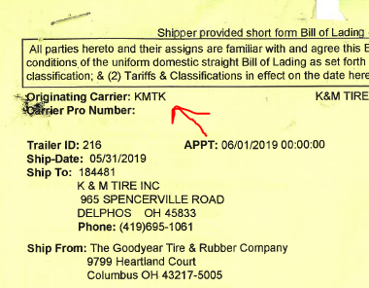
  - Location 47 & 51 – Equipment Supply Co, Hennessy, and Tire Rack (TR) invoices go in packer box
  - Invoices for Accounts Payable Clerk: Examples AmeriPride/D&D Trucking/Freight Summaries, Bill of Lading for NM Transfer, Brown, Old Dominion
  - Invoices from Purchasing – file in file cabinet next to Accounts Payable Clerk (these have been checked for pricing variances, typically say OK on the top)
- File paperwork
  - Put oldest paperwork in packer box (3rd drawer down in file cabinet) first
  - Once Packer box is full, date a box, and box it up. The beginning range date will be the date on box in drawer, the ending range date will be the date of the last item boxed. (Ex. 6/1/19 – 6/7/19) Put the next day (Ex. 6/8/19) on the box in the drawer.
  - Boxes are stored in the storage room by Purchasing, we keep these boxes for 90 days and then dump them in recycling, bringing the boxes back to use next time

Expense Reports/Check Requests
This procedure displays the process to take in the event where an employee would need to be reimbursed for travel expenses but has not obtained a company credit card or does not have access to concur.

Manual Expense Reports

Receive Manual Expense reports from employees.
- Get approval from employees’ supervisor for payment
- Go through receipts and verify the amount listed on the expense report is correct. Receipts should be in order as they appear on the expense report.
- Ensure mileage reimbursement is calculated at $.50/mile
- Breakfast and Lunch is reimbursed 100% up to $10
    - Must have detailed receipt, alcohol will not be reimbursed
- Dinner is reimbursed 100% up to $20
- Must have detailed receipt, alcohol will not be reimbursed
- Mike Ewert – K&M to pay $40/mo. for phone (loc 48)
- Clint Stafford - K&M to pay $40/mo. for phone (loc 68)
- Write Vendor # and GL(s) used with amount on the top of the report
- Use ‘WK END (end date)’ OR ‘TRIP (date)’ as invoice number and follow Entering A/P procedure.

Check Request – Fundraiser
This procedure shows that K&M only pays half the price per ticket. Therefore K&M will match funds collected from employees.

This procedure is used for Fundraisers. K&M matches the total collected.
- Receive completed check request form, verify form was completed to its entirety
  - F:\Accounts Payable\Public\Check Request\Fundraiser.docx
- MaddenCo.
  - 2. Accounts Payable; ENTER
  - 2. Invoice Input & Update Menu; ENTER
  - 1. Input Vendor Invoices; ENTER
  - Store number will always be 001; ENTER
  - Put in your username for “Created by or last changed by user” to show what you have Entered
  - F6 to Add Invoice
  - Enter Vendor number or press F4 to locate the vendor
    - Type in a few letters of the vendor sort name
    - Put a 1 by the Vendor name to select
  - If you need to create a new vendor follow New Vendor Set-Up Procedure
    - ENTER
  - Write down Vendor Number on Check request form
  - Enter the Invoice number
    - Pork/Chicken Dinners MMYY
  - Enter the Invoice date
  - ENTER
  - Enter total check amount next to ‘Amount’
  - ENTER
  - Enter total amount
  - TAB to Enter the appropriate G/L
    - Post to donations 5020-1-1
  - Write down G/L on check request form
  - ENTER
  - F3 – verify the information you Entered is correct
  - F3
- File by vendor number

Employee Reimbursements
In this instance where HR would need a check request due to payroll or a PTO cash out issue, this procedure explains the process of how AP would handle reimbursements for employees.

- Receive completed check request form, verify form was completed to its entirety
  - F:\Accounts Payable\Public\Check Request\Check Request Form (Non-Employee & K&M Cares).docx
- MaddenCo.
  - 2. Accounts Payable; ENTER
  - 2. Invoice Input & Update Menu; ENTER
  - 1. Input Vendor Invoices; ENTER
  - Store number will always be 001; ENTER
  - Put in your username for “Created by or last changed by user” to show what you have Entered
  - F6 to Add Invoice
  - Enter Vendor number or press F4 to locate the vendor
    - Type in a few letters of the vendor sort name
      - Employees are sorted by last name
    - Put a 1 by the Vendor name to select
    - If you need to create a new vendor follow New Vendor Set-Up Procedure
    - ENTER
  - Enter the Invoice number
    - Check Requests = ‘CK REQ MMDDYY’
    - Weight Watchers = WW REIMB MMYY
    - Gym Membership = GYM REIMB MMYY
    - Race Reimbursement = RACE REIMB MMYY
    - Tuition Reimbursement = TUITION REIMB YY
    - Mail Run = MONTH YEAR
  - Enter the Invoice date
  - ENTER
  - Enter reimbursement amount next to ‘Amount’
    - Travel to post office for mail run is $3/day
  - ENTER
  - Enter the reimbursement amount
    - If posting to several G/L’s each amount must be listed separately
  - TAB to Enter the appropriate G/L
    - Travel to post office for mail run is coded to 5660-1-1
    - Most reimbursements will be posted to employee benefits 5680-location
  - ENTER
  - F3 – verify the information you Entered is correct
  - F3
- File by vendor number

Company Check Request

- Receive completed check request form, verify form was completed to its entirety
  - F:\Accounts Payable\Public\Check Request\Check Request Form (Non-Employee & K&M Cares).docx
- MaddenCo.
  - 2. Accounts Payable; ENTER
  - 2. Invoice Input & Update Menu; ENTER
  - 1. Input Vendor Invoices; ENTER
  - Store number will always be 001; ENTER
  - Put in your username for “Created by or last changed by user” to show what you have Entered
  - F6 to Add Invoice
  - Enter Vendor number or press F4 to locate the vendor
    - Type in a few letters of the vendor sort name
    - Put a 1 by the Vendor name to select
    - If you need to create a new vendor follow New Vendor Set-Up Procedure
    - ENTER
  - Enter the Invoice number
    - If no invoice number, be descriptive to show what invoice is for
  - Enter the Invoice date
  - ENTER
  - Enter reimbursement amount next to ‘Amount’
  - ENTER
  - Enter the reimbursement amount
    - If posting to several G/L’s each amount must be listed separately
  - TAB to Enter the appropriate G/L
    - F4 to search G/L’s
  - ENTER
  - F3 – verify the information you Entered is correct

  - F3
- File by vendor number

Electronic Invoices

A/P Email Inbox – Invoices
The AP email inbox is dedicated to ensure that all emails containing invoices that are service and utility related are received. This is an efficient way for an AP team member to extract specific items.

- Open your email and navigate to the A/P Invoices section on the left-hand side, see below screenshot
    - If you do not have access – IT will have to get you access

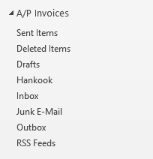

- Click on ‘Inbox’
  - Print invoices from inbox pertaining to services, utilities, etc. (Accounts Payable Clerk will print all items pertaining to tires and AP exhaust parts)
    - Ace Hardware invoices need moved into ‘Pending’ folder
    - Pitsenbarger invoices need moved into ‘Pending’ folder
    - If need to pull from online use F:\Accounts Payable\Shared\Lists\Vendor Logins & Contacts.xlsx
  - Almost all invoices will need approval, check Invoice/Sorting Guide for tips
    - For all invoices that need approval, forward email to warehouse manager (ensure invoice number is in subject line)
    - Stamp with ink stamp and put location on GL line
  - Before deleting email/invoice verify it printed
  - If Utilities or Monthly Invoice follow Tracking, Coding, and Entering Utility & Monthly Invoices Procedure
  - File invoices in folder ‘Waiting for Approval’
  - When invoices are approved, pull from ‘Waiting for Approval’ folder and fill in the remainder items from the ink stamp
    - Okay to pay: Date
    - Vendor Number
    - GL Number
    - Approved By: person who approved
- Enter invoice into MaddenCo by following Entering A/P Invoices Procedure
- File in cabinet by vendor number

Verizon
This procedure shows how AP uses Verizon and our Intranet system to allocate bills.

- Download invoice copies from Verizon’s website:
  - Login to Verizon https://www.verizon.com/business/solutions/enterprise/
  - Under “Billing”, choose View all invoices
  - Click on the invoice number
  - Click on Download
  - Click on PDF
  - Open the PDF file
  - Print only Page 1 of the invoice
  - Save a copy of the invoice to: F:\Accounts Payable\Shared\Invoices - Vendor\VERIZON (Name as invoice number)
  - Repeat steps 1c-1h until all invoices are copied and saved.
- Download raw data file:
  - Click on Manage Accounts
  - Click on Reports
  - Click on Show More
  - Click on Raw Data Download
  - Select a period and press download
  - Open up file RDD_KM_TIRE_YYYYMM.ZIP (year and month downloaded)
  - Move files to desktop or personal folder
  - Right click on Account & Wireless Summary_YYYYMM.txt and open with Excel
  - Review the file for usernames/cost centers
  - Save the file in the same folder, but as an Excel Workbook
  - Right click on Account Summary_YYYYMM.txt and open with Excel
  - Save the file in the same folder, but as an Excel Workbook
- Go to Intranet
- Under Accounts Payable, choose Verizon Wireless
- Choose Import Data Tab
- Choose the file that was created in step 2j
- Choose Upload Verizon Statement
- Choose the file that was created in step 2l
- Choose Upload Verizon Statement
- Choose a report under End Billing Date and Choose Run Report
- Fix any allocations that may appear in red
- Click on Apply Adjustment and apply any adjustment that appears under this tab
- Choose Accounts Payable Posting/Report
- Verify the amount on the Intranet matches the invoice total. (If the total is off more than $2.00, check with IT to have them find the discrepancy.) Proceed to step 13 after discrepancy has been resolved.
- Choose Post to Accounts Payable, click OK if you are ready for the invoices to be exported into MaddenCo
- Click on Usage Report and e-mail Warehouse Managers
- Click OK
- E-mail a Usage Report to President.
  - Click on Usage with Cost Report
  - Click on Export to Excel
  - E-mail the file to President
- When the files are sent to MaddenCo (from Step 13 above), they are sent in a WtApr status (waiting for approval). The status needs to be changed to ready in order to be processed for payment;
  - Go to MaddenCo
  - 2. Accounts Payable; ENTER
  - 2. Invoice Input & Update Menu; ENTER
  - 1. Input Vendor Invoices; ENTER
  - Store Number = 001; ENTER
  - Under Show only: Vendor = 881
  - Put a 2 by the first invoice to edit and press ENTER
  - If the amount in MaddenCo matches the invoice total, ENTER on this screen.
  - F3 on the next screen (the status for this invoice should now be Ready)
  - If the amount is incorrect, TAB to the Amount and change it; ENTER.
  - On the next screen at the bottom shows “Remaining to distribute”. Put a 2 on the first line item and Press ENTER. Change the total by the amount “remaining to distribute” and press ENTER.
  - F3 (the Status for this invoice should now be Ready
  - Repeat steps 16g-16l under all invoice totals in MaddenCo match the Verizon invoice total and the Status total is ready for all invoices.
- File the invoices in the appropriate miscellaneous invoice folder in the AP filing cabinet.

Receivers

Printing and Matching Receivers
To ensure payments are completed correctly, the following procedure outlines the steps of matching receivers with invoices in order to make a valid transaction.

**Morning**
Verify all receivers were printed for previous day (these receivers will be in MaddenCo or on receiving table)
- MaddenCo
  - 1. Tire Dealer, ENTER
  - 3. Inventory Menu, ENTER
  - 3. Inventory Receivers, ENTER
  - Enter Location Number (refer to manual list; described below in step 2), ENTER
    - Status should be ‘P’
    - Change ‘Exclude processed receivers’ so it is blank
    - Change ‘Date’ and ‘thru’ to previous days date

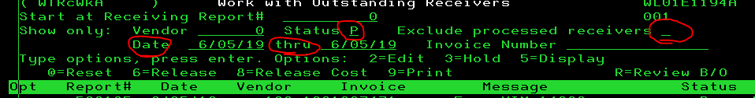

  - Refer to manual list, print receivers (if applicable) after the last recorded report number
    - Never print receivers with line item ‘Auto Inter-Company’
  - Update manual paper to record last printed receiver, cross off when complete for previous day
  - Continue for all locations until all receivers are printed, match with invoices (procedure starting at step 4 below and Enter same day (follow ‘A.P Vendor Invoice Entry’ Procedure)

**After Initial Morning Check**
Receive paperwork OR print receivers from MaddenCo
- Print Receivers in MaddenCo
  - 1. Tire Dealer, ENTER
  - 3. Inventory Menu, ENTER
  - 3. Inventory Receivers, ENTER
  - Enter Location Number
  - Put 9 on the line next to the report number needing to be print (refer to manual list described in step 2)
    - Never print receivers with line item ‘Auto Inter-Company’

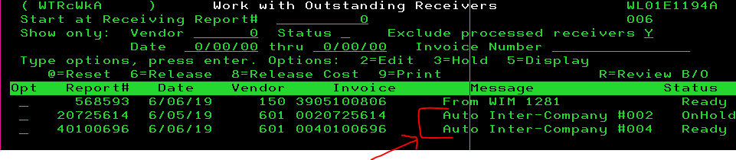
  - ENTER, ENTER
- Track printed receivers
  - To keep track of printed receivers, write down last report number printed by location (keep manual list each week)
- Receive Receivers on Receiving Table – some locations have people at corporate receive for them, these invoices will be brought over
  - Verify all receivers have been brought over by checking MaddenCo as if you were printing the receivers and updating the manual list
    - If all receivers have not been brought over, check the one(s) that were not to see who created them by putting a 5 on line next to report number, the ‘Last changed by’ will tell you the user who last updated that receiver.
      - If this user is a manager, you will print the receiver. (some receivers do not get put on table, such as will call)
      - If the user is someone at corporate, paperwork may be out of order, or not yet brought over, obtain copy of receiver
    - Staple receivers and backup paperwork together
- Matching Invoices to Receivers
  - Look at receiver to determine vendor and location, pull invoice from folder
    - Match Receiver’s ‘Vendor Reference’ to invoice(s) and piece count
      - If piece count does not match, receiving may have been done incorrectly or we have incorrect billing. Check packing list to see what piece count is, if you do not have packing list, call warehouse manager and see how many tires were actually received. Contact person that received the tires in and have them fix the error. If incorrect billing, contact vendor.
      - If over OR short tires, (warehouse will let you know) follow ‘Over/Short’ Procedure
      - If tire was miss-tagged, follow ‘RGA’s – Mistags’ Procedure
- Put matches together with invoice on top in piles sorted by location, these invoices will be Entered next business day
    - If receiver has more than one invoice put the largest invoice on top and write the number of total invoices for the receiver on top, on the next invoice write 4080-1-1 on the top of the invoice (put in piles as described above in 4b).
    - If invoice has more than one receiver write number of receivers on top of invoice, in MaddenCo put 5 on report number line of smaller receiver amount. Write 2320-location on receiver and bottom right-hand amount.

- BKT or Speedway Receiving/Matching/Entering
  - Pull invoices from top drawer of the receiver cabinet. These invoices are grouped together by the wire/ACH payment date.
  - Find correct invoice based on summary sheet of packet and date, then flip to correct invoice and pull it out.
  - Put remainder of the packet away, if all invoices are dated put summary in appropriate BKT or Speedway file in the AP paid filing cabinets.
- Prepare Journal Entry
- On the top of the invoice, write the receiver number and date.
- Get the receiving amount from the AP screen in MaddenCo
- 2. Accounts Payable, ENTER
- 2. Invoice Input & Update Menu
- 1. Input Vendor Invoices, ENTER
- Enter Store location on receiver
- Look for the receiver number and write down the amount on the invoice.
- Delete the receiver from Maddenco

- Write the below and the invoice.
- 2320-location = Receiving Amount (found in MaddenCo above)
- 1310-location = total due on the invoice
- 4055-1-1 = SPL Discount
- 4085-1-468 = BKT Specials Disc. And Earlybird Spring Buy Discount
- 4080-1-1 = variance
BKT Example Below: (if Speedway, remove 4055-1-1 and 4086-1-468 lines)

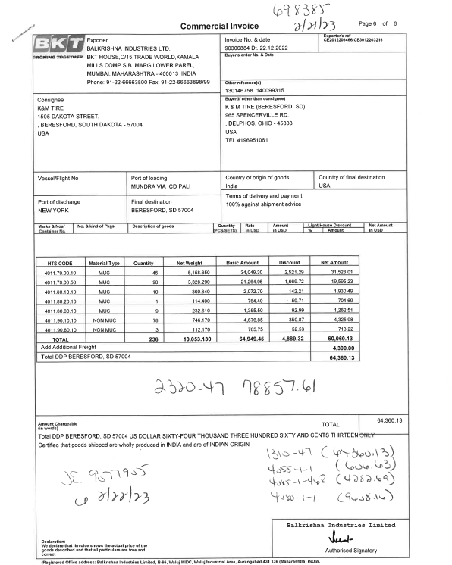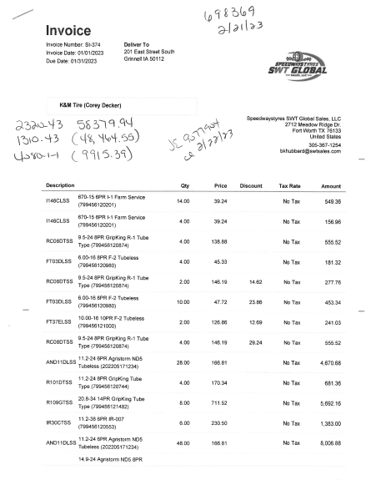

- Make a General Ledger enter:
  - 3. General Ledger
  - 2. Input & Update Menu
  - 1. Work with outstanding JEs
  - F6 – Create New JE
  - Change to the current year/period
  - Description = Post Recr XXXXXX / INV xxxxxxxx
  - Make entries as written on the invoice as describe above.
  - Write the JE # and date on the invoice

- Remove the invoices from 1310 Spreadsheet found at F:/Accounts Payable/Shared/Lists/1310 Reconciliation/GL 1310
- Search for the invoice number
- Put the amount posted to 1310 in the Inventory Rec’d column and enter the receiver date in the Inventory Rec’d Date column. Save/Close the spreadsheet.
- File the invoices in the appropriate BKT or Speedway files in the AP Paid filing cabinets.
- The receivers can be thrown away (recycled).

BKT & Speedway Payment Process
BKT
- Sam Bastian of BKT will send emails with invoices attached for containers that in transit.
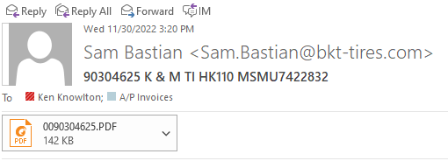

- Save attached invoice to BKT Invoices folder on F Drive:
F:\Purchasing & Pricing\Public\BKT & SPEEDWAY INVOICES

- Sam Bastian will also send a weekly statement of invoices with the container estimated port arrival dates. This statement will be sent over early in the week (Monday or Tuesday). Below is an example of what you’ll see:
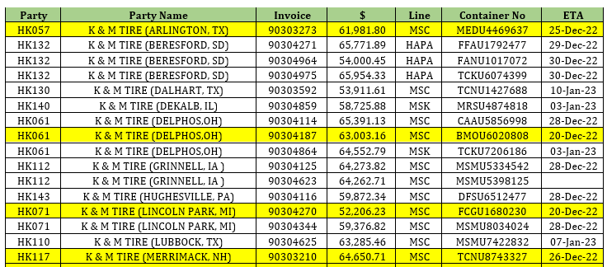

- Now determine what invoices need to be paid and when. Sam will highlight the ones that must be paid during the current week (see step 3’s chart), however if there are other invoices whose dates are somewhat close to the highlighted invoice dates, a good practice is to also have them paid this week as well.
- For example, Invoice 90303273 from the above chart is highlighted and has an ETA of 12/25. Invoice 90304271 has an ETA of 12/29. Since these dates are so close together, you would want to go ahead and pay that invoice as well.
- Anything past a week or so of the highlighted invoices’ dates can wait until to be paid until a later date.
- General guidelines to determine wire dates outside of going off of the highlighted invoices on the statement: The Wire Date will be the Wednesday prior to the Port ETA unless the Port ETA falls early in the week. If the Port ETA falls on a Monday or Tuesday, the Wire Date will be the Wednesday before.
Examples:
    - If Port ETA is 12/31/2021 Wire Date is 12/22/2021
    - If Port ETA is 12/27/2021 Wire Date is 12/15/2021
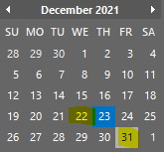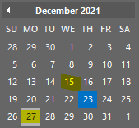

Speedway

- Invoices are sent from Speedway via email.
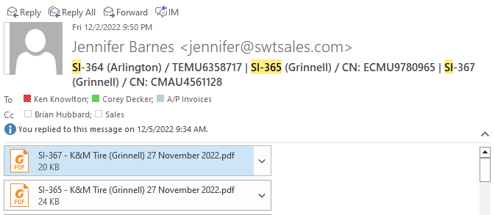

- Save attached invoices to Speedway Invoices folder on F Drive:
F:\Purchasing & Pricing\Public\BKT & SPEEDWAY INVOICES
- Once we have received the corresponding Bill of Lading email, we can then pay the invoices. In the below example, we have received the Bill of Lading for SI-365, so invoice SI-365 can be paid on the next Wednesday when we normally pay.
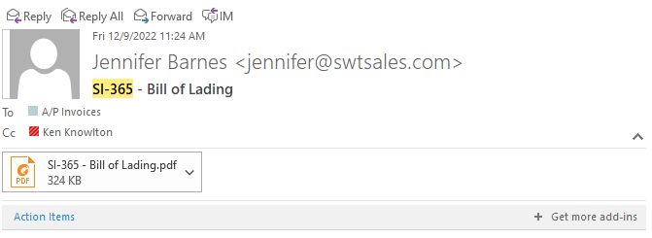

- The Bill of Lading does not necessarily need to be saved but you can if you so choose.

RGA / Mistags
This procedure was established in the case of delivering error in which a tire does not match the label where then a return and credit process will follow.

- An invoice is created to the A/P vendor for the tire we were supposed to receive
  - Must list the actual size and description of the tire we actually received on a message line
  - Must list the DOT # from the tire we received on a message line
  - These invoices are brought up to us from the Adjustment/Will Call Department

- Fill out the claim form for the vendor (Cooper/MC and Carlstar have their own claim form)
  - List the product # tire was supposed to be
  - List the description of the tire that was to be received
  - X the column miss-labeled

- In the comment section state the tire is miss-labeled and is actually a (give size/description of tire actually received) and list the DOT #
  - Request an RGA to return the tire(s)
  - Request call tag and pick-up info (if we do not return on our route trucks)
  - We return Cooper/MC, Goodyear, Continental/General on our own route trucks from Loc 1
- When you receive the RGA, make a copy to attach to the back of the RGA.
  - Make a copy of the invoice and black out the dollar amount.
  - Attach a copy of the RGA to the original invoice and any supporting paperwork and file in the over/short folder for that vendor by the National Accounts Supervisor.
  - Attach the invoice copy (that has the dollar amounts blacked out) to the RGA and place in the file folder for Adjustments/Will Call on the stand by the Konica4 printer

- The route driver is to have a copy of our invoice signed by the warehouse to show proof of return and that copy is to be given to A/P
  - Attach the signed invoice to the back of the original claim.
  - Watch for credit to come from vendor.

Over/Shorts

This process outlines how K&M handles shipments that have missing or extra tires (included more than invoiced/listed on delivery receipt.) The process starts at the Warehouse then moves to the WAMs and finally to AP to submit to the vendors.

- The Warehouse counts the tires received and mark the BOL, both K&M copy & driver’s copy (If 2 separate docs) and notifies the Warehouse Administration if any variances are found. NOTE: This step is very important because if it is not documented correctly and at the time of the delivery, it will likely be declined.
- If a variance is found the Warehouse Administration Manager with either invoice (for shortages) or credit (for overages) the vendor for the tire variances. Note: K&M receives and pays the full invoices amount issued by the vendor, including tires not received or excluding extra tires received. The invoice/credit issued to the vendor corrects our inventory count and eventually will offset with credit or debit from the vendor from the filed claim.
- There are thresholds for writing off an overage or shortage rather than submitting a claim.
  - The over/short amounts need reviewed by the Warehouse Administration Managers (WAMs) and sent to the AR team to for write off if they fall below thresholds listed in (i,ii.).
    - Overages/credit in the amount of $500 or less needs adjusted off to 4080-1-XXX
    - Shortage/invoice in the amount of $100 or less needs adjusted off to 4080-1-XXX
      - GL 4080-1-XXX where XXX is 3-digit vendor code.
- If an RGA was obtained by purchasing for an overage, do not file a calm.
  - NAB will be notified so it can be added to the RGA Tracker.
- Once the vendor’s offsetting invoice is received it ill be applied to the K&M invoice by NAB.
  - AP Team will file amounts over thresholds with the vendors per the guidelines below (see G.)
- If the variance is over the claim threshold amounts, a Claim will need to be filed and the WAM is required to send a copy of the invoice/credit and the BOL to accountspayable@kmtire.com.
  - AP will find the original invoice where K&M Tire was billed for the tire shorted. All documents will be printed off.
  - The BOL will be saved at F:\Accounts Payable\Shared\Over Shorts & Misc Credits and then in the appropriate month.year folder (example 11.22)
    - Save as date being submitted/ vendor abbreviation/ original invoice number/ BOL (example:11-24-22 GY 25536894 BOL)
- If the WAM does not have the appropriate documentation (including the BOL) noting the variance, they will contact the Carrier or work with the warehouse to get the appropriate documents.
- Continental & Carlisle Claim are processed quicky by these vendors. The responsible AP Clerk will hold these claims for 5-7 days before filing in case the warehouse resolves the over/short and reverses the K&M invoice to the vendor. This eliminates filling claims unnecessarily.
  - Note: Some vendors have over/short claims are being held for 5-7 days.

Log on the Over/Short Log Sheet Summary- Excel Spreadsheet
- F:\Accounts Payable\Shared\Over Shorts & Misc Credits\Log Sheet Summary.xlsx
- Fill in a new line for each line of the K&M invoice exactly how it appears on the K&M invoice because sometimes the vendor will pay each line at separate times.

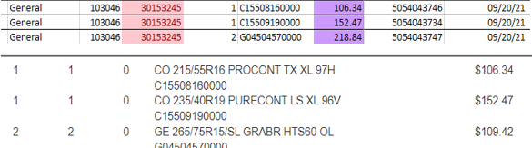

- If K&M invoices is a reversal of an over/short- put “reversal-claim submitting” in the “notes” column.
  - If the original invoice has not been submitted- have AR offset the invoices, put the date in the “NAB entry complete” column and offset in the “notes” column.
  - If the claim has been submitted but no credit/debit has been received from the vendor - find the original email and let them know to disregard the claim. Take to AR to be offset, put date in the “NAB entry complete” column and offset in the “notes” column.

  - If the claim has been submitted and we received credit/debit back from vendor - find original email and let them know to reverse the claim and put the reversal invoice on the log sheet with “reversal-claim submitted” in the “notes” column.

To file claim with Vendor (except Hankook and Continental)

- American Omni, Carlstar, Michelin, API, and Kumho have their own forms and all other vendors use the generic form that is set up. F:\Accounts Payable\Shared\Over Shorts & Misc Credits\Claim Forms. Hankook and Continental will not have a completed claim form, it is filed online.
- Once completed this form will saved in the month and year of filing the claim at F:\Accounts Payable\Shared\Over Shorts & Misc Credits
  - File save name is as follows: “Day filed – Vendor Abbr-Vendor invoice number(s) claim form” EX: 11-24-22 GY 25536894 Claim Form
- After the form is completed, you will email the claim form and signed BOL/packing list to the appropriate vendor (Do not scan our invoices to the vendor). Hankook and Continental claims are not emailed, file those online. The contact emails will be on the Log Sheet summary under the ”Contacts” tab. F:\Accounts Payable\Shared\Over Shorts & Misc Credits\Log Sheet Summary.xlsx

- Staple the invoice on top of all the supporting documents and file in the over/short folders in the file cabinet by National Account Supervisor.

To file a Hankook Over/short claim:
- The website to file this claim is http://portal.hankooktireusa.com/login/login.do;jsessionid=CC9D984735523A88D461449505B46B12
  - Username=207185
  - Password=207185

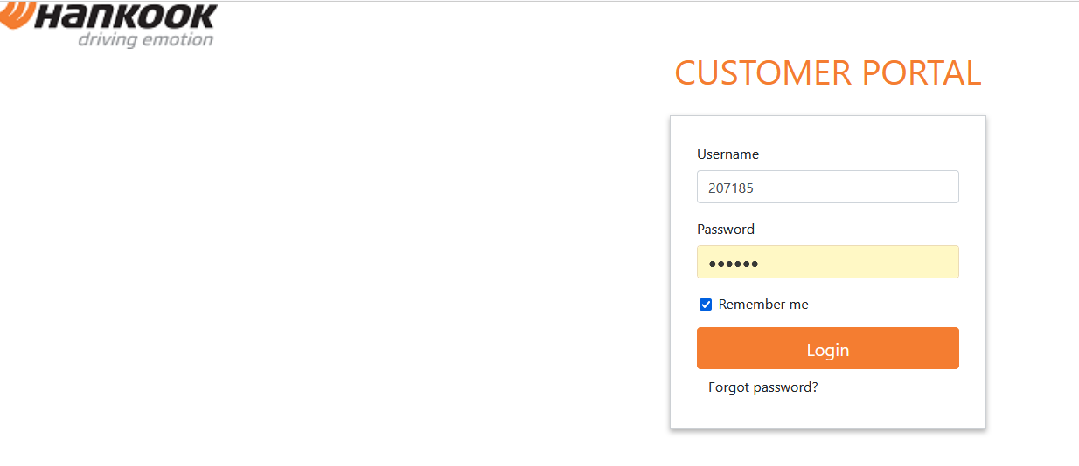

- This will take you to the claims dashboard in this system.

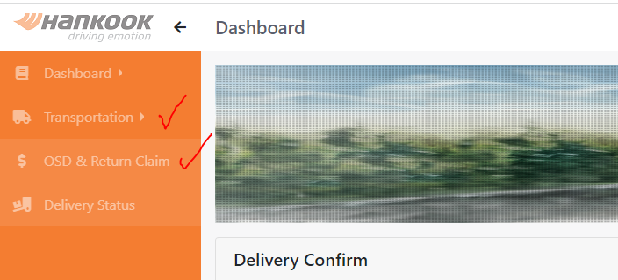
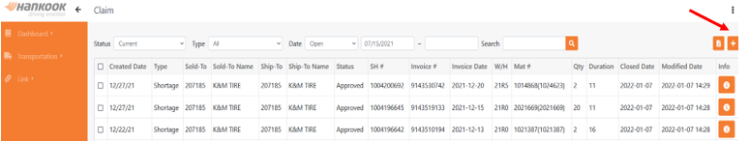

- To add a claim, hit the “+” in the top right-hand corner of the screen. Complete the pop-up screen with the information. All claims are made by original sale invoice so you may have more than one claim per K&M over/short invoice.

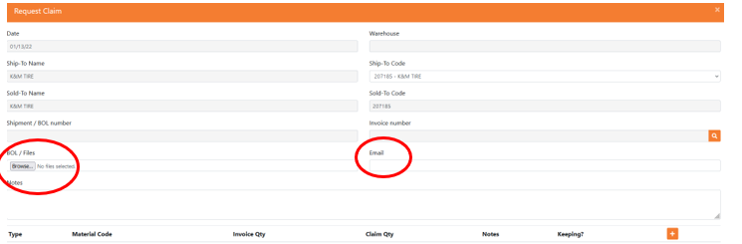

- Click the down error in ship to code and select the warehouse the over/short invoice was ran out of

- Invoice number- hit the magnifying glass. A pop up will appear/. Put original invoice # in the box and click search. Then once it pulls up all the materials for that invoice, find the material numbers for the over/short and click the little box off to the left of the material numbers to select. Once all of them are selected click select. If you start putting a material number in the material box it will pull it from the material list below. All overages need to be marked as keeping.

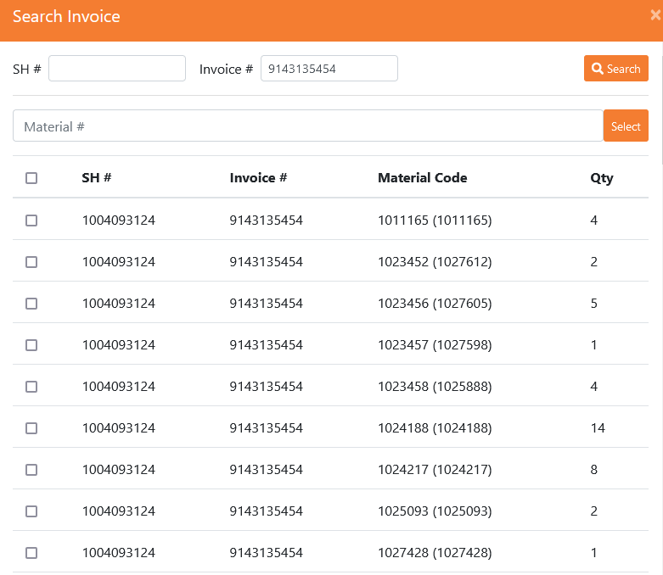

- Click the down error in ship to code and select the warehouse the over/short invoice was ran out of

- Invoice number- hit the magnifying glass. A pop up will appear/. Put original invoice # in the box and click search. Then once it pulls up all the materials for that invoice, find the material numbers for the over/short and click the little box off to the left of the material numbers to select. Once all of them are selected click select. If you start putting a material number in the material box it will pull it from the material list below. All overages need to be marked as keeping.



- Once you hit select all the over/shorts will appear in the bottom section of the below snip it. All overages mark as keeping.
  - Type is usually shortage or overage. It is a drop-down choice box. To add a line to show overage you will click the “+” at the top right of the list.
    - On shortages you will see the Invoice Qty and then put the correct qty in the claim for the shortage on the load.
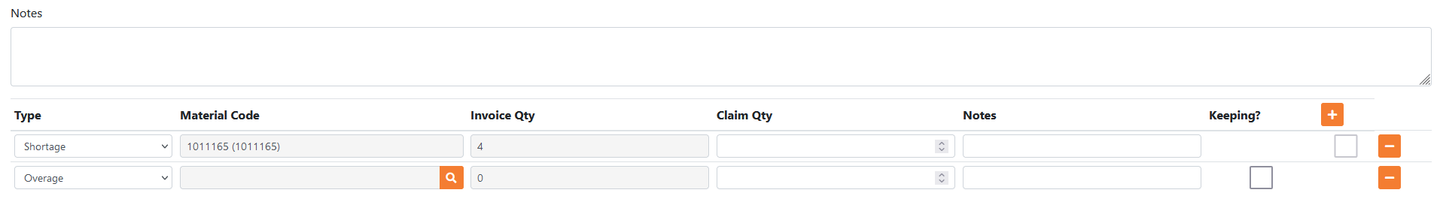

  - If you just want to do overages repeat step 5 and then hit the + at the bottom on the below snip it. In type select overage, hit magnifying glass and search material number, put in claim quantity, and mark keeping.

- Hit the “Browse” button to attach the BOL you just saved from the previous section. If you have multiple invoices - just attach the same BOL file to each claim filed.
- Make sure the correct email for replies is in the “Email” box.

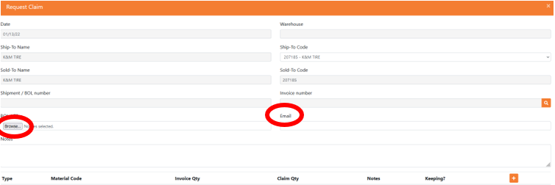

- When all lines for this invoice claim are complete - click the submit button at the bottom of the screen.
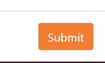

- Repeat steps 2-10 for all original sale invoices on each claim.

- Continental over/short filing (All claims need the BOL from the carrier marked short) Contact Old Dominion at Customer.Service@odfl.com for POD of BOL. Give them the pro number and they will get you the POD. Save this where you save the other BOL’s with a 2 behind it - they also want the original invoice attached to the claim.

  - Go to www.contilink.com
    - Username- donnab
    - Password- Pearl789
    - Click on claims, claims: Pricing/Shipping, and then on over/short shipping claims.

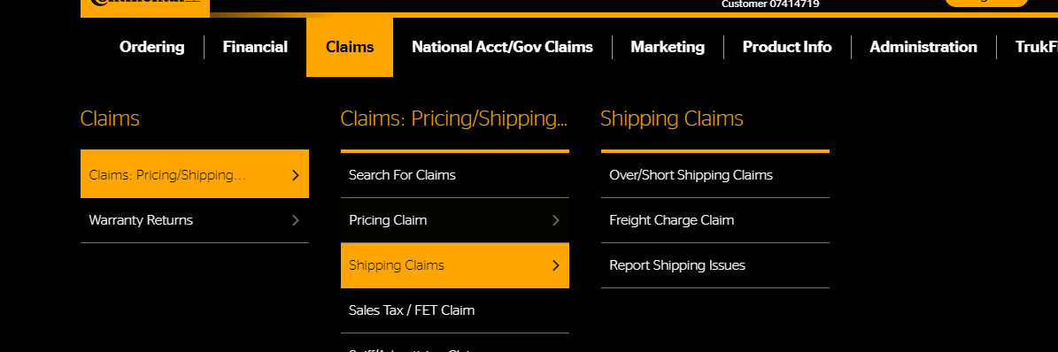

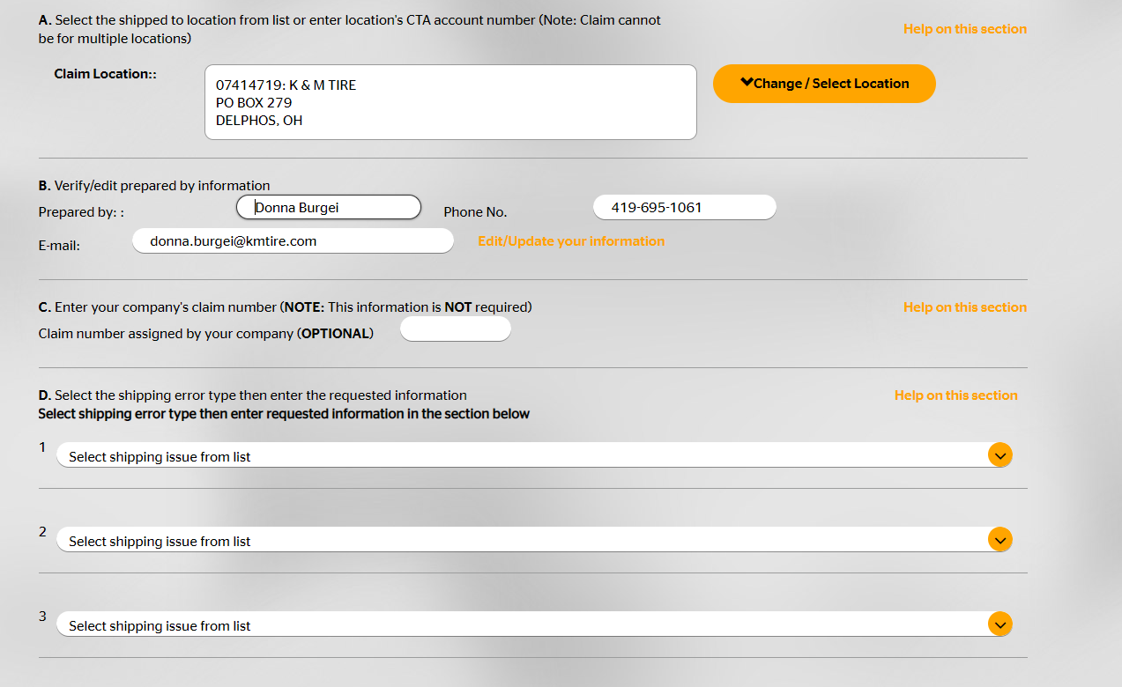

- Claim location: click change/select location and pick the warehouse location for the over/short.
- Prepared by; put your name.
- Phone number: Put K&M’s phone number.
- Email: your email
- Claim number assigned by your company: put the K&M invoice number.

- Click the drop-down error in the select shipping issue from list. Select short or overage and the below will appear:

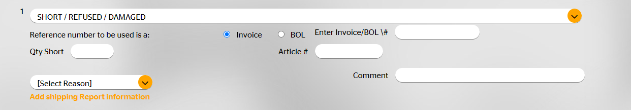

- The invoice number will be the original invoice number.
- Qty short: quantity on over/short invoice
- Article #: input the part number without the letter in front.
- Select Reason: always use Quantity Discrepancy
- Comment: put the BOL number.
- If you have more than one line on the over/short invoice repeat steps 1-5 until all are on the form

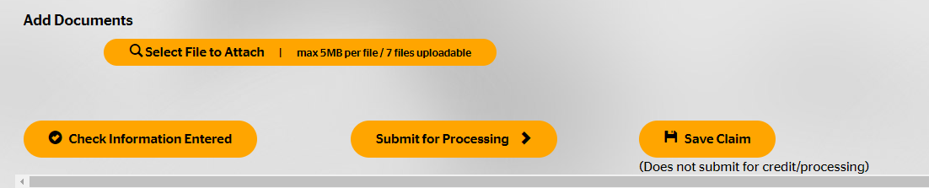

- Click select file to attached and attach the BOL’s and the original invoice number.
- Once complete click “Submit for Processing.”
- A page will pop up with a claim number on it. Write that on the over/short paperwork and put it on the log sheet in the vendor claim column.

When a credit (for shortages) or invoice/debit (for overages) is received from the Vendor - match it to the correct over/short documentation from the Over/Short folders in AP.
- Complete the Log Sheet Summary:
  - Put the date you are going to do the NAB entry in NAB Entry Completed
  - Enter the credit/debit # in the Vendor Invoice/Credit column.
  - Enter the amount we received back in the Vendor Amount column.
- Post the NAB entry in MaddenCo to clear the K&M invoice with the Vendor Invoice/Credit
  - Go into MaddenCo follow the below prompts in each menu list:
  - 1 – MaddenCo Tire Dealer System
  - 1 – Tire Dealer System
  - 11 – National Account Billing Menu
  - 1 – National Account Billing Entry
  - Enter in location of the K&M invoice number (example location 1 the invoice starts with a 1)
  - Tab to the Vendor spot and put in the vendor number you are entering (ex. Bridgestone 102)
  - Tab to “created by” or “last changed by user” and input your MaddenCo username
- To start a new, NAB Credit memo select F6.
  - Invoice number = invoice number of the vendor invoice
  - Invoice Date = invoice date off the vendor invoice + enter
  - Credit Amount = the total amount of the vendor invoice. (If a credit no negative with the amount, if a debit negative goes with the amount) +
  - Tab to the discount area and put the discount in the amount area, not the discount%, +
  - Due date = refer below
    - Customer = 108 or the customer number on the K&M invoice (depends on what class the customer is)
    - Tab to Amount and put in the amount of the K&M invoice then hit + enter.
    - Next screen - start at invoice number put in the K&M invoice number hit + enter.
    - Put the same amount of the K&M invoice on the line that it pulls up if it matches the K&M invoice number then hit + enter.
    - Once the screen refreshes - make sure your amount remaining is 0 and the amount on that line is 0 as well.
    - Hit F3
    - Change the difference GL to correct acct. 4080-1-XXX

- Bridgestone
  - Discounts-yes
  - Due Date- whatever is on the Bridgestone invoice.

- General
  - Discount-yes
  - Due date- 20th of next month for credits; 20th of 3 months out for debits

- Goodyear
  - Discounts-yes
  - Due date- Whatever is on the vendor invoice.

- Hankook
  - Discounts-only on debits
  - Due date- credits same as invoice date; debits on vendor invoice

- Pirelli
  - Discounts- no; except on debits
  - Due date-credits same as invoice date; debits on vendor invoice

- Michelin
  - Discounts- no
  - Due date- Whatever populates in Madden Co

- Yokohama
  - Discounts- yes
  - Due Date- credits same as invoice date; debits check in due date area.

- Falken
  - Discounts- only on debits
  - Due Date- credits same as invoice date; debits whatever populates in Madden Co

- Kumho
  - Discounts- discounts only on debits
  - Due Date- credits same as invoice date; debits down in left hand corner

- Nexen
  - Discounts- no
  - Due Dates- credits same as invoice date; debits on vendor invoice

Audit and Follow Up
This process is completed monthly and explains how to audit K&M vendor statements against the spreadsheets where open claims are tracked. When a credit / debit invoice is received from the vendor for a claim, it is cleared from the spreadsheet. Follow up with the vendor is completed once the claim is 30 days old. Note: Most vendor invoices are saved under F: Accounts Payable/ Shared/ Invoices – Vendor

- K&M Vendor Customer Statements received via email.
  - On the first day of each month, all vendor customer statements are emailed to national.accounts@kmtire.com
  - If a statement(s) for a vendor that is not received and you have over/short invoices, contact Credit & Collections department to have statement(s) emailed each month.

- Convert Emailed Statements to Excel and Save
  - Save Text Document
  - Open Blank Document in Excel
  - Open Text File to Convert
  - Text Import Wizard box will open, click Next.
  - Move Vertical lines as needed – the lines are where the columns will be.
  - Click Next
  - Click Finish
  - Click Ok
- Save as ‘Name of Vendor MM.YY’ (MM.YY is the month and year of the statement (previous month))
  - (F: Accounts Payable/ Shared/ Over Shorts & Misc Credits/ Aging Reports/ Vendor Name/ YYYY)

- Audit Saved Statements (above step) Against Spreadsheets
  - Open spreadsheets:
    - Log Sheet Summary: Over/Shorts (F: Accounts Payable/Shared/Over Shorts & Misc Credits/Log Sheet Summary)
    - RGA Log Sheet: RGA – Return Goods Authorization (F: Accounts Payable/Shared/RGA Log Sheet)
    - Mis-Tag Log Sheet copy 2.0: Mistags (F: Adjustments/Public/Mis-tags/Mis-Tag Log Sheet copy 2.0)

  - Match up invoices & amount
    - Highlight the ‘amount’ cells yellow that match the statement,
    - Make notes for future reference on the statement
    - Place a ‘g’ for Good on Over/Short claims
    - Place an ‘RGA’ for RGA claims
    - Place ‘Mistag’ for Mistag claims

- Review Outstanding Items (Skip if all Statement and Spreadsheet Invoices Were Matched)
  - Check to see if invoice was cleared in Madden Co (steps below)
    - If so, clear the line item on the Log Sheet Summary Spreadsheet by inputting the date in which the invoice was cleared in Madden Co
    - If not, view the Invoice in Display Invoice (Intranet) and look for notes/comments on the invoice such as “Reverse Invoice #xxxxxx or RGA or Mistag or Over/Short”
      - Reverse Invoice #xxxxxx & a claim has not been filed with the vendor (for the original invoice):
        - Send customer number and invoice numbers to Accounts Receivable department and request they be offset in Madden Co
          - If the amounts do not offset; find the variance.
            - If under $100, or under ($500): Have Accounts Receivable department write off the variance to 4080-1-XXX
            - If over $100, or over ($500): Reach out to Accounts Payable to see if they have the BOL for the invoice (include Vendor Name, Invoice Number, Invoice Amount), if Accounts Payable doesn’t have the BOL request from the Warehouse Administration Manager (contact information located on Contact tab of the Log Sheet Summary)
      - Reverse Invoice #xxxxxx & a claim has been filed with the vendor for the original invoice, contact vendor to have claim voided.
      - Reverse Invoice #xxxxx & a claim has been resolved, follow steps to file claim.
      - Mistags – notify Adjustment Supervisor
      - RGA - add the invoice to the RGA spreadsheet.
      - Over / Short – follow steps to file claim
      - Vendor Purchase
        - Occasionally, a vendor will purchase tires from K&M and their purchase will go on their vendor account.
          - If these go past the due date on the statement, follow up with the vendor on status of payment.
      - Make a note on the K&M vendor customer statement to track what you have found.
    - If invoice was issued more than 30 days ago
      - Check notes from previous months (F: Accounts Payable/ Shared/ Over Shorts & Misc Credits/ Aging Reports/ Vendor Name/ YYYY)
      - Check to see if invoice was cleared in Madden Co (steps below *Exhibit 2)
    - If invoice was issued within last 30 days
      - Check to see if invoice & BOL has been received from Warehouse Administrative Manager
If not, contact Warehouse Administrative Manager for the correct location.
          - Contact information is listed on Log Sheet, Contact Tab, in columns H-J
          - Follow up as needed and ensure the signed BOL gets to the Accounts Payable Clerk in a timely manner.

- Follow up on all claims that are 30 days old – Reference ‘Date Filed with Vendor’ column.
  - Review any notes listed on the ‘Log Sheet Summary’ spreadsheet and the last email communication by searching ‘Vendor Invoice Number’ in the National.Accounts email folder, under Over/Shorts/Misc Credits – Vendor Name
    - For Continental / General: review status of all claims online
      - Contilink.com
      - Click ‘Claims’
      - Click ‘Claims’ Pricing/Shipping’
      - Click ‘Search for Claims’
      - Choose parameters.
      - Click ‘Search for Claims’
      - Click the CTA Claim# for the correct claim and see the status and reason (right side)
        - For ‘Rejections’ – Signed Clear: Send K&M invoice details to the Director of Finance and request approval for the invoice be written off to correct vendor GL account.
          - If approved, send details to Accounts Receivable department and request invoice be written off.
        - For ‘Rejections’ – No Reason: Skip to step 6b.
        - For ‘Completed’ – Includes Credit / Invoice Number: Lookup invoice number on F Drive (see procedure description for path)
          - Invoices should also be available on the contilink website under ‘Financial.’
          - Lookup in Madden Co to see if it has been input:
            - 2 - Accounts Payable, ENTER
            - 3 - Inquiry Menu, ENTER
            - 2 - Vendor Status with Total, ENTER
            - ENTER
            - Input Vendor Number ‘141’
            - Input Invoice Number, ENTER
        - For ‘Completed’ – Does Not Include Credit / Invoice Number: Skip to step 7c.
        - For ‘Submitted’: Skip (Needs additional time to process)
    - For Hankook: review status of all claims online
      - https://eportal.hankooktire.com/
      - Click ‘Transportation’
      - Click ‘OSD & Return Claim’
      - Search for claim (using vendor invoice number)
        - Status: In progress – give claim another 30 days to be processed

        - Status: Rejected - send K&M invoice details to the Director of Finance and request approval for the invoice be written off to correct vendor GL account.
          - If approved, send details to Accounts Receivable department and request invoice be written off.
        - Status: Rejected (no reason) – Skip to below step (6b)
      - Follow up by forwarding last email communication and requesting an update (for Continental/General or Hankook, work up email and include details, all claims are submitted online)
        - Contacts are listed under the ‘Contacts’ tab of the Log Sheet Summary spreadsheet.
      - Move the sent email in email box to the ‘Over/Shorts/Misc Credits’ – under Vendor Name in the National.Accounts email folder.
      - Input the date the follow up email was sent into the first available ‘Follow Up Date’ column of the Log Sheet Summary spreadsheet.
- For Aging claims (older than 90 days) – Reference ‘Date Filed with Vendor’ column.
  - After 90 days, unresolved items are escalated to the VP of Purchasing & Pricing, VP of Finance & Technology, and the Controller to determine if follow ups with vendors should continue.
    - Follow up as directed by VP’s listed above.
      - If another attempt is made to contact the vendor, move the sent email in email box to the ‘Over/Shorts/Misc Credits’ – under Vendor Name email folder.
      - Input the date the follow up email was sent into the first available ‘Follow Up Date’ column of the Log Sheet Summary spreadsheet.
      - If the decision is made to write off the claim, send an email to AccountsReceivable@KMTire.com and request to write off K&M Invoice.
        - Enter the date in column A on the Log Sheet Summary, enter “written off” in column O under Written Off/Denied.
        - Record who approved the write off under “notes.”
        - Save email approval with claim supporting documentation on the F drive under Accounts Payable\Shared\Over Shorts & Misc Credits under mo.yr claim was filed.
  - At 120 days – all outstanding items at or over 120 should be sent to the VP of Purchasing & Pricing, VP of Finance & Technology, and the Controller to determine if follow ups with vendors should continue or if the claims should be written off. Accounts Payable will track write-offs in the Log Sheet Summary and updates will be provided in the Monthly Communication.
    - Follow up as directed by VP’s listed above.
      - If another attempt is made to contact the vendor, move the sent email in email box to the ‘Over/Shorts/Misc Credits’ – under Vendor Name email folder.
      - Input the date the follow up email was sent into the first available ‘Follow Up Date’ column of the Log Sheet Summary spreadsheet.
      - If the decision is made to write off the claim, send an email to AccountsReceivable@KMTire.com and request to write off K&M Invoice to correct vendor GL account 4080-1-XXX.
        - Enter the date in column A on the Log Sheet Summary, enter “written off” in column O under Written Off/Denied.
        - Record who approved the write off under “notes.”
        - Save email approval with claim supporting documentation on the F drive under Accounts Payable\Shared\Over Shorts & Misc Credits under mo.yr claim was filed.
- Create Spreadsheet for all claims (I do this to easily show what vendors I contacted with specific claim information)
  - Create New Blank Spreadsheet (Skip if spreadsheet has been created for the month)
  - Copy the header of the Log Sheet Summary spreadsheet (row 1) (Skip if spreadsheet has been created for the month)
  - Paste into the Blank Spreadsheet (Skip if spreadsheet has been created for the month)
  - Copy the rows of the Log Sheet Summary spreadsheet of all items that were followed up on and paste into the blank spreadsheet.
  - Save the new ‘blank’ spreadsheet as Over Shorts Follow up Review – MM.YY under F: Accounts Payable/ Shared/ Over Shorts & Misc Credits/ Aging Reports

Exhibit 1
View invoice in K&M Intranet
- Enter “display invoice” in Search box in upper right corner.
- Enter the invoice number in the box.
- Click Run Report
OR
View Invoice in Madden Co: Note: if you are unable to figure out what the invoice is for, contact the person who created the invoice.

- Hit ‘ESC’
- Page down to find Invoice History Inquiry
- 1 - on ‘Invoice History Inquiry, ENTER.
- Input invoice number, ENTER.
- 5 - to display invoice

Below is an example of an RGA:

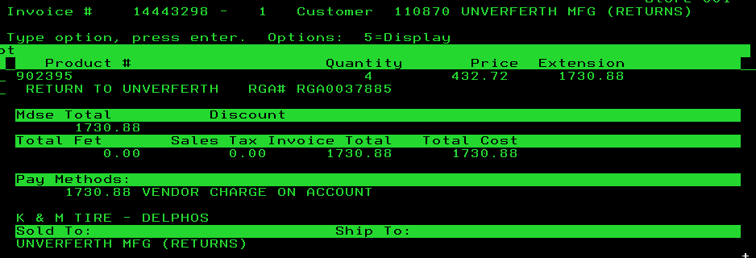

Below shows that Chris Maye created this invoice:

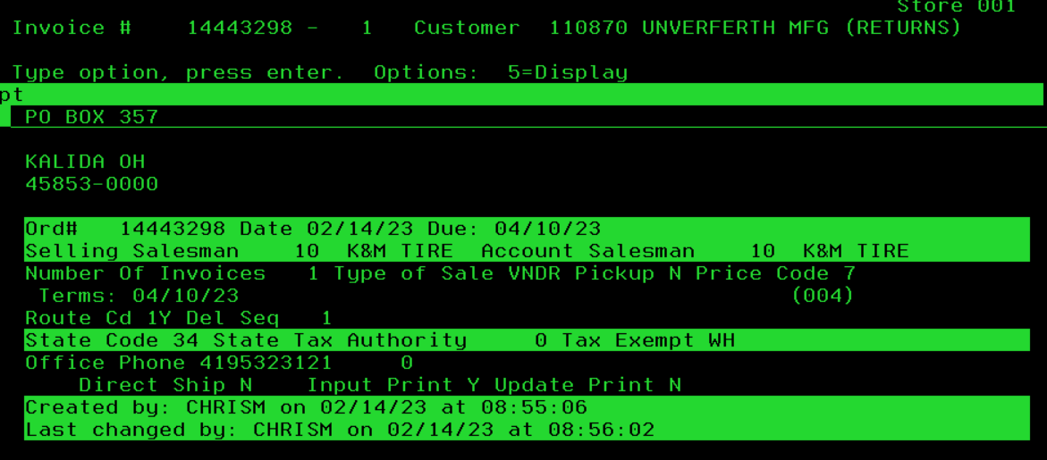
Exhibit 2
Check to see if the invoice has cleared in Madden Co: This process will show if an invoice is still open or if it has been cleared.

- 1 - Tire Dealer System, ENTER.
- 1 - Accounts Receivable Menu, ENTER.
- 8 - Customer Inquiries Menu, ENTER.
- 1 - Customer Balance Inquiry, ENTER.
- Type in the Store Number, ENTER.
- F9 – input customer number, ENTER (found on Aging report or under “Customer” on the invoice copy).
- 6 - ENTER (to display account history) next to customer number.

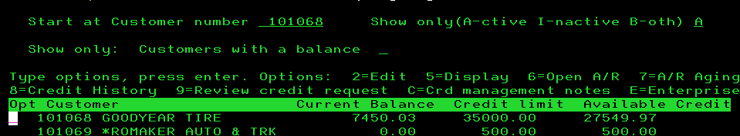

- Find correct invoice, input 5, ENTER.

In the below example, the invoice was cleared with vendor invoice# 94029520:

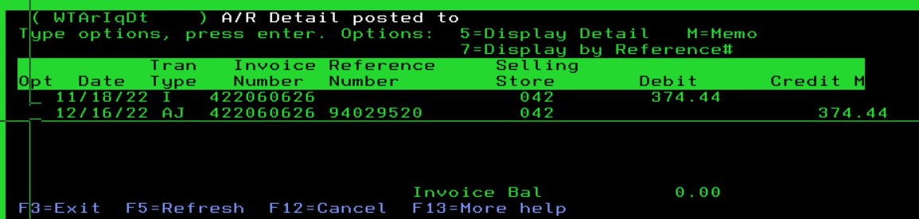

In the below example, the invoice is still open:

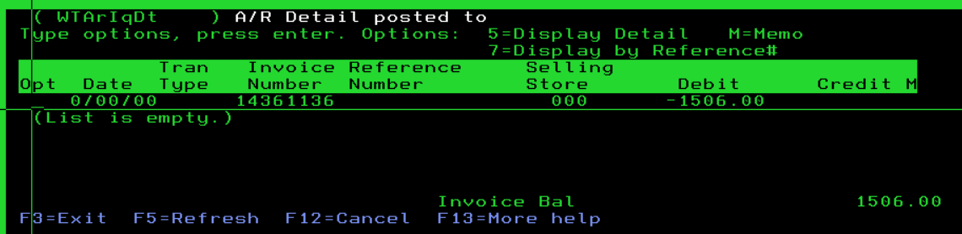

Filing Incoming Invoices-Receiving
Invoices are received from National Accounts for Firestone, Goodyear, Continental/General, Falken, Hankook, Yokohama, Michelin, Cooper/MC they are put on top of file cabinet between Pam & Staci, always pick the due date with the most discount available.
- Calculate discount (if applicable) and/or due date and Sort by following below guidelines
    - Always put total page on top, unless Cooper
    - If direct ship to customer – figure discount and give to Purchasing
  - Bridgestone/Firestone – look for PTO matchup when filing invoices

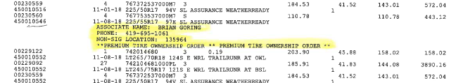

  - Carlstar – calculate 1% discount based on ‘subject to discount’ column’
    - Some invoices have special terms which doesn’t allow discounts
  - Continental / General
    - All should have ship to K&M location, if not it is probably donna’s
  - Cooper – total piece count, put numerical order
    - If freight on invoice (total page on bottom) add GL 3920-1-1 on the top of the first page
      - Loc 1 & 4 should always receive freight credit, if not, how did it ship? If we picked up, we need freight credit
  - Falken – figure discount on the Product total line
  - Goodyear – look for PTO matchup when filing invoices (this
  - First Choice – 2% on product only, total piece count
  - Hankook – calculate discount by choosing biggest discount amount
  - Pirelli – Write down discount date (15 days out)
  - Yokohama – NO DISCOUNT (discount will be figured at time of payment, all credits must be used before discounts are calculated)

- File Cooper in numerical order (do not separate by location) newest to the back in file cabinet

- Put each vendor together in location order (example: all Carlisle together separated by location)
  - Pull vendor folder from file cabinet and put same locations together (newest to the back) while looking for un-matched receivers and PTO matchup for Bridgestone and Goodyear
    - Receivers will be located in the front of each location OR ‘Misc Packing List’ folder
    - If PTO matchup is found (match PO), paperclip to back of invoice. Write GL 1580-1-1 on the top of the invoice. Cross off of post-it-note in folder if applicable
  - If receiver is found and matched, put in pile to be entered same day

A/P Email Inbox-Receiving
- Open your email and navigate to the A/P Invoices section on the left-hand side, see below screenshot
    - If you do not have access – IT will have to get you access



- Click on ‘Inbox’
- Premium Tire Ownership Program (PTO) Bridgestone OR Goodyear – receive from purchasing, print, sort by location and put first in locations folder in file cabinet. GL 1580-1-1 (example: find location 56’s stack, and put in front of invoices)
  - If more than one PO make list on post-it-note- and put on the top of PTO forms
- Outside (OS) Vendor Orders – receive email from purchasing, print, put paperclip on paper, file to the back under ‘Misc Inv – need matched & coded for computer’
- Print invoices from inbox pertaining to tires and AP exhaust parts (the AP Specialist will print invoices pertaining to services, utilities, etc.)
  - Kumho – if MOPAR program leave in inbox for National Accounts Team
  - Pirelli – delete out of folder
  - Some invoices & credits will need printed and forwarded to Equipment Office Assistant
    - Challenger Lifts
    - Delegard
    - Group 31
    - Hennessy – (Hennessy has mileage, labor and parts)
    - Hunter
    - ISN
    - Martin Industries
    - Neu Tool
    - Rotary Lift
  - Speedway/BKT
    - Receive email from purchasing summarizing the invoice amount/location/wire date with a copy of the invoice attached
    - Print the email to show the detail and invoice (for BKT or Speedway)
    - Verify the email $ amount to the invoice amount
      - Write the wire date by the invoice total
      - Put the G/L 1310-Loc # at top of invoice
    - Staple the email to back of invoice copy and file in top drawer in either the Speedway or BKT folder

- Once invoices have been printed, figure discounts
  - American Pacific (API) – 1% discount if paid in 10 days
  - Alliance Tire Group (ATG) – if freight charge, put amount and GL 3920-location on top of invoice,
  - Carlstar – 1% discount
  - Challenger Lifts – 1% discount if paid in 10 days
  - Delegard – 2% discount
  - Direct Performance – No Discount/Check pricing on Denise’s spreadsheet
  - ESCO – 2% discount if paid in 10 days
  - First Choice – 2% discount & add up piece count
  - Group 31 – 3% discount
  - Hennessy – No discount (Hennessy looks weird and has mileage, labor and parts)
  - Hunter – 5% discount if paid in 10 days
  - ISN- No Discount, send credits to Audra as well
  - Martin Industries – No Discount
  - Neu Tool – 2% Discount
  - Nexen – calculate discount
  - Rotary Lift – Discount amount listed
  - Tech – Discount listed
  - Trelleborg – Can have a 1-3 % discount, write down discount amount
    - Two accounts #391 and #392 (check name line to know which one it is)
- Put each vendor together in location order (example: all Carlisle together separated by location)
  - Pull vendor folder from file cabinet and put same locations together (newest to the back) while looking for un-matched receivers
    - Receivers will be located in the front of each location OR ‘Misc Packing List’ folder
  - If receiver is found and matched, put in pile to be entered same day
  - Unerverth – vendor typically faxes invoices as well, check for duplicates.

A/P Entry-Receiving
This procedure explains how to accurately enter vendor invoices for payment on tires/equipment that was received.

- Madden Co
  - 2. Accounts Payable, ENTER
  - 2. Invoice Input & Update Menu, ENTER
  - 1. Input Vendor Invoices, ENTER
  - Store number will location that received merchandise; ENTER
  - Change ‘Show Only: Status’ to W (this will show only pending receivers)
  - *OPTIONAL* Change ‘Show Only: Vendor’ to Vendor Number (this will only show specified vendor)
  - If Speedway OR BKT invoice, skip to step 12
- Change Invoice OR Vendor Number, must change Postmaster V# 111 to Hankook V# 1110 (if needed, if not skip next step), may also need to pay different vendor for tires received (example: when the Ag/OTR Sales Manager pays for items personally)
  - Put ‘C’ in the field next to the appropriate invoice number, ENTER
    - Change Vendor Number, if applicable, put F4 on line to find Vendor Number
    - Update Invoice No to the invoice number on Vendor’s Invoice
    - ENTER
- If holding Goodyear or Continental/General file in bottom drawer until available to enter
- Enter ‘2’ in the field next to the appropriate invoice number, ENTER
  - Verify or change invoice date according to what the invoice date is
  - Verify or change the total invoice amount next to ‘Amount’
    - Check to ensure invoice is in US Currency
  - TAB down to enter any discount (if applicable) – Always choose the largest discount amount and correct due date
    - Calculated as per the terms arranged with each vendor, which is found on each invoice
      - Alliance 210 – NO DISCOUNT
      - Carlstar 136 – Discount OR split payments
      - Yokohama 162 – NO DISCOUNT
  - Enter Due Date
    - Bridgestone/Firestone – auto fill (do not change date)
    - Falken 170 – next check run
    - Mickey Thompson 113 – next check run
    - CMA – next check run
  - Number of payments, update if more than one payment will be made for the invoice, ENTER
- Verifying & Correcting GL Breakout for Invoice
  - F4
    - If there is a handwritten amount post the written amount to the listed GL
      - GL 3920-Loc may be used for freight differences
      - Cooper gives freight credit and should be posted to GL 3920-1-1
    - If there is more than one receiver post small receiver(s) to GL 2320-location
    - F3
  - F4 post the ‘remaining to distribute’ to GL 4080-1-1
  - F3
  - Review entries to ensure accuracy
  - If split payment, hit F7, update if needed, F3
- Multiple Invoices per receiver, if applicable
  - Enter remainder invoices manually and post to GL 4080-1-1
    - F6
    - Enter Vendor #, Invoice #, Date, ENTER
    - Complete steps 4b-4e
    - Post invoice amount to GL 4080-1-1
  - F3, check to ensure accuracy
- If there was more than one receiver, must delete the one manually entered in step 5aii
- Status is changed from “WtApr” to “Ready”
- Flip completed invoice and receiver over into pile
- Starting at step 1f, continue onto the next invoice until all A/P is entered
- When all A/P is entered, view each location and check for invoices Waiting Approval
  - If invoices are waiting approval, where is the invoice? May need to request from Vendor
- Speedway & BKT Invoices
  - Delete AP Entry(s) and make JE based on the information recorded during the printing and matching process
    - 3. General Ledger, ENTER
    - 2. Input & Update Menu, ENTER
    - 1. Work with outstanding JEs, ENTER
    - F6 –Create New JE
    - F2-Get a Reference #
    - Year/Period will be 3 months past current month (example: January 2019 will be 2019/04)
    - ‘Description’ is a quick description as to why the Journal Entry is being made, (EX. SPEEDWAY #1110 RECR #569011 WIRED 5/22/19) ENTER
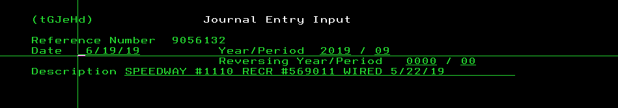

    - Put in GL and amount listed on receiver (handwritten from previous day)
    - Ensure Debit’s and Credit’s equal
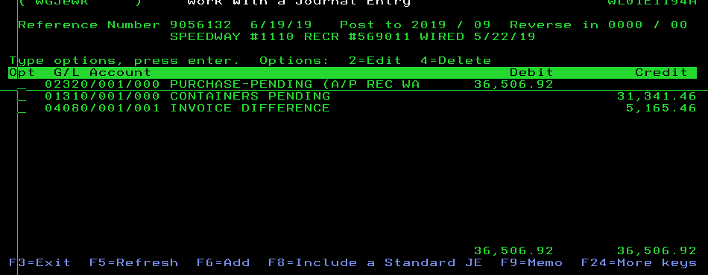
    - F3
  - Log on 1310 Reconciliation Spreadsheet
    - F: Accounts Payable/Pam Riley/ GL 1310 recon/ GL 1310 recon
    - Find invoice by location
    - Enter the invoice amount in the ‘Received’ column (c) and ensure balance updates to 0
  - Make 1 copy, original to file with Paid Invoices, copy to file in packer box.

Invoice/Receiver Variances
Purpose: This SOP explains how to process Mighty Tire Receivers & Invoices.
- When a Mighty Tire Receiver is received/printed, look for the Mighty Tire Invoice to match.
  - If there is no Mighty Tire Invoice reach out to Warehouseadminmanagers@KMTire.com to get the invoice.
- Send the Mighty Tire Invoice to the Real Estate Accounting Managerr to be paid by Tribune Trucking.
- Tribune Trucking will issue an invoice to K&M Tire to replace the Mighty Tire invoice & to match to the Mighty Tire receiver.
NOTE: (refer to SOP 5.2 Affiliate & Mighty Tire Billings in Real Estate Accounting Manager’s SOP binder for their process.)
- Payment will be processed to Tribune Trucking based on the invoice matched & entered in Maddenco.

Processing Payments and Credits

New Vendor Setup
While not all vendors are setup in our system, this procedure shows how a new vendor would be setup in order to pay.

- MaddenCo
  - 2. Accounts Payable; ENTER
  - 1. Maintenance Menu; ENTER
  - 3. Vendor Maintenance; ENTER
  - Store number will always be 001; ENTER
  - F6 to Add Vendor
  - Obtain a new vendor number from the Available Vendor Number spreadsheet
    - F:\Accounts Payable\Shared\Lists\Available Vendor Numbers.xlsx
      - Choose between Vendor, Misc. Vendors, Employee, Spiff Vendors
    - Log the vendor number used
    - If we will be purchasing tires or exhaust parts (for resell) ensure vendor is supplied with Sales & Use Tax Exempt Form found at F:\Accounts Payable\Shared\Forms\Sales & Use Certificates\Uniform-Sales-and-Use-Certificate.pdf
      - If K&M is located in a specific state and doesn’t have a tax-exempt number, request one (this should only happen as K&M opens more stores)
  - Enter Vendor number
  - Enter Vendor Name as it appears on the invoice or W9 tax form
    - Obtain W9 if service, legal, or medical services are being provided
  - Enter a Sort Name (to be used to find the vendor later); TAB
    - If employee use their last name
    - If rent, use rent
  - Enter Vendor Address, City, State, Zip
  - Enter Phone
  - Enter Terms Code (found on vendor invoice)
    - Press F4
    - TAB until you find the appropriate terms for the vendor and put a 1 by the line number to select
    - ENTER
    - G/L can be filled if the same G/L will always be used; otherwise, leave blank.
    - Payable # is always 10
    - Fill in the Federal ID number of the Vendor
      - If paying rent, providing services, legal & professional, cash/car/item prize, or medical must have W-9 on file (print and file)
        - If W-9 is provided, but do not need to print 1099, fill in Federal ID, print and file
    - If 1099 needs to be sent, Enter correct 1099 code for reason of 1099
      - AA – Medical
      - AB – Miscellaneous
      - AC – Legal
        - If you need to create new 1099 code hit F4, F6, complete as follows:

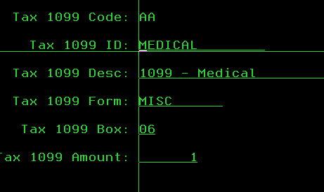
      - Enter
      - F3
    - 1099 Y/N Opt
      - Type in Y if the Vendor needs to receive a yearly 1099
      - Type in N if the Vendor does not need to receive a yearly 1099
    - ‘Miscellaneous Vendor’ If a Miscellaneous Vendor number is selected from f. above, put a Y in this field; otherwise, leave as N
    - ENTER
    - F3
- If we will be paying via ACH, obtain ACH information from payee and include details with first ACH transfer paperwork
- Create ACH transfer paperwork
  - F: Accounts Payable/ Shared/Forms/Recurring Entries/ACH-Wire Transfer Request
  - Complete the follow fields: Payable to
  - Save in same path, as the name of vendor paying
  - Print several forms
  - Create folder and file blank forms in top file cabinet
- Add ACH vendor to procedure ACH

Setting up a Vendor for ACH Payment through MaddenCo
This procedure describes the steps in which AP would pay vendors through ACH.
- MaddenCo
  - 2. Accounts Payable
  - 2. Invoice Input & Update Menu
  - 5. Select Invoices to be Paid
  - Store to be used – 000 (All stores)
- F6
  - Enter due date
    - For Wednesday check run pull to Friday.
    - For Friday check run pull to the next Thursday

  - Payables Code = 20
  - Enter
  - F3 to exit
  - F7 to view items selected
  - F9 to print listing on Konica4
- Work through the report by pulling unpaid invoices filed by vendor and matching the invoice number and amount. (We do not keep invoices for Cooper, Hankook, or Yokohama).
- Run Check on paper
  - 1. Tire Dealer
  - 2. Accounts Payable
  - 2. Invoice Input & Update Menu
  - 6. Update Invoices to be Paid
  - Obtain a check number from F:\Accounts Payable\Shared\Lists\Available Wire Numbers
  - Tab to “Check Type”, Press F4, Type 1 to Select ACH Payment Transaction
  - Enter
  - Put in the Starting Check Number again
  - The effective Date for ACH will be the next day. If running check for a WIRE use the current date.
- Print check remittance
  - ESC
  - 1 next to ‘work with printer status’
  - 8 next to ‘P273K0Z1’
  - 2 next to AP 8x11
    - Change printer to PKONICA4
    - Enter
  - Remittance is automatically e-mailed to Vendors.
- Add Vendor Name and amount to K&M INC bank ledger
  - F:\Accounting\Shared\Bank Ledgers\K&M Inc.\JP Morgan Chase\AP\
- Staple copy of check, remittance, and invoices together
  - Give to the Accounting Manager to initiate, from there it will be given to the Controller or Staff Accountant to transfer funds, ACH paperwork will then be returned to you when complete.
- Submitting NACHA File
  - File is automatically created after step 4 above. The file is located at F\Accounts Payable\Shared\ACH – Shortcut
  - Login to JPMorgan Chase Bank
  - Select Payments
  - Select U.S. ACH (Nacha) under Imports
  - Select Import File located at the top right-hand corner of the screen
  - Select Browse and select the file just created (F:\Accounts Payable\Share\ACH Shortcut
  - You will have to refresh the screen.
  - Select the file and Click Import
  - Verify the total is correct
  - Select the file and Click Submit
  - Confirm Submit

A/P Miscellaneous Invoice Approval
Invoices can be submitted to AP for payment in a variety of ways:
Invoices@KMTire.com
Mailed to PO Box 279, Delphos, OH 45833
Deliver to the AP office area located in the west wing.
- Invoices to be paid by K&M Tire
Invoices to be paid by K&M Tire should be billed to K&M Tire. Please be sure to give our venders the correct name when placing an order for a project, item or service. This helps to avoid confusion and duplicate payments.
  - If an invoice is received that is our expense but billed to another customer, please request an invoice billed to K&M Tire or provide the approved invoice to AP and request that we contact the vender for an invoice billed to K&M Tire.
  - If an invoice billed to K&M Tire is not possible, or payment is being requested without an invoice (i.e., donation); please complete the Check Request form.
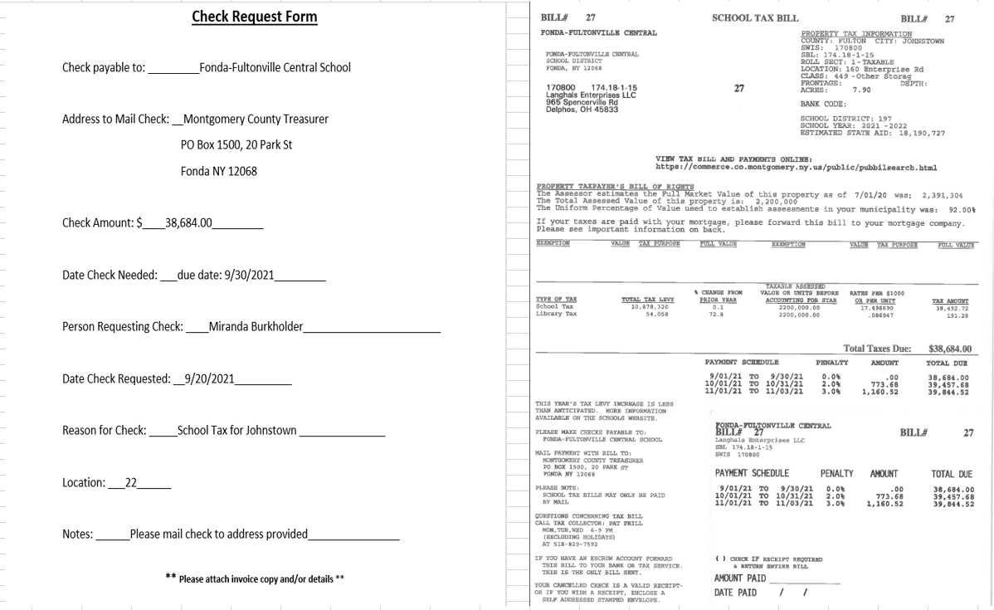

  - All invoices, except utilities and a few other items (see list) require approval. Below are acceptable approvals.
    - If you have a hard copy of the invoice:
      - Circle the amount to be paid
      - List the location of the expense
      - Sign invoice
      - Submit for payment as listed above
    - If you have a packing slip or receiving slip from a purchase placed on account (i.e., OReilly’s, Ace Hardware, Pittsenbargers), sign the slip and turn into AP. This can be matched with the invoice when it’s received and will be processed for payment. *Please provide details regarding purchase (see #4 below).
    - If invoice is received via email provide the following in an email with the invoice attached to Invoices@KMTire.com:
      - Vender name
      - Invoice number
      - Amount approved to pay
      - Location of the expense
        - NOTE: vender name, invoice # and amount in the subject line of the email is acceptable.
  - Acceptable email approval:
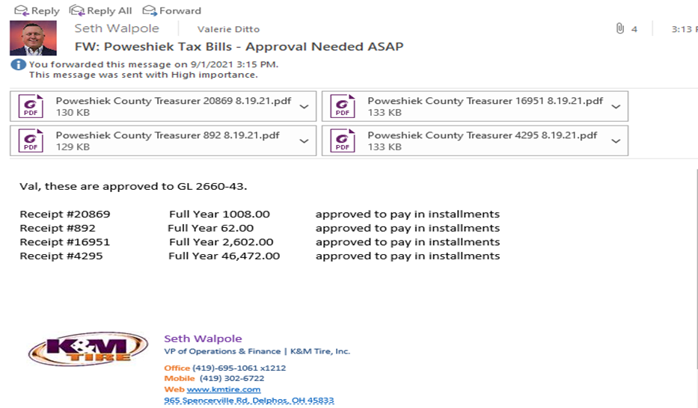
  - Provide detail regarding the invoice:
    - If the invoice being approved is for supplies or for a repair of some sort or for a specific project (Wise installation), it is very helpful when placing the expense in the correct GL account code to have this detail. It’s often difficult for us to know if it’s for a truck repair and some other type of repair when detail isn’t provided.
      - Is the repair a truck repair, warehouse repair etc.?
      - What location is the repair for? This is especially helpful when approval is from someone who is not dedicated to one specific location all of the time.

Invoices for the items listed below do not require approval.
BFS Retail Orkin
Delphos Fuel & Truck Wash Quill
Lane’s Warehousing Temp Services
Microtel Utilities
Monark Uniforms
OEC Propane (various venders)
AP will print all approvals via email and attach to the invoice.
The following venders often have signed receivers or packing slips.
- Check Miscellaneous folder for matching signed receivers or packing slips.
- Once invoice is matched to signed receivers or packing slips, it can be entered in MaddenCo for payment.

Entering AP Invoices
This procedure was made to ensure that all invoices need to be entered accurately with correct due dates.

Do not Enter invoices that are paid by statement until all invoices from last month are paid, refer to Statement Checklist to see which ones have not been received F:\Accounts Payable\Shared\Lists\Statement Checklist Corp - 2021.xlsx
All utilities and monthly invoices are tracked at F: AccountsPayable/Shared/Utilities/Monthly Utility Checklist (year), follow Tracking, Coding, and Entering Utility and Monthly Invoices Procedure before proceeding.
- MaddenCo.
  - 2. Accounts Payable; ENTER
  - 2. Invoice Input & Update Menu; ENTER
  - 1. Input Vendor Invoices; ENTER
  - Store number will always be 001; ENTER
  - Put in your username for “Created by or last changed by user” to show what you have Entered
  - F6 to Add Invoice
  - Enter Vendor number or press F4 to locate the vendor
    - Type in a few letters of the vendor sort name
    - Put a 1 by the Vendor name to select
    - ENTER
  - Enter the Invoice number
    - Credit Check Requests = ‘CK REQ MMDDYY’
  - Enter the Invoice date
  - ENTER
  - Enter total invoice amount next to ‘Amount’ – check to ensure invoice is in US Currency
    - Travel to post office for mail run is $3/day
  - TAB down to Enter any discount (if applicable)
  - Verify or change due date according to when the invoice is due
  - Number of payments, update if more than one payment will be made for the invoice, ENTER
  - Enter the invoice amount
    - If posting to several G/L’s each amount must be listed separately
    - Check to ensure invoice amount is in US Currency, if not, obtain invoice in US Currency amount
  - TAB to Enter the appropriate G/L
    - Sales – Location in which they are traveling for, if vehicle or meeting expense code based on allocation found at F: Human Resources/Public/Employee allocation
    - Warehouse – home location unless traveling to fill in for person
    - ROM’s – location in which they are traveling for, vehicle maintenance/repairs is corporate (1-1)
    - If someone is traveling to help the warehouse, it will be coded to the warehouse they are helping, if traveling for managers meeting, will be allocated to their home location
    - Travel to post office for mail run is coded to 5660-1-1
    - If traffic violation, should be payroll deduct, code to 5400-1, if driver paid post to 5400 (location of driver)
    - If posting as an asset (over 5K), list the information on spreadsheet F:\Accounts Payable\Shared\Lists\ASSETS(year)KM Asset List by completing date, vendor, description, more information, amount, account number. Must also track at F: Accounts Payable/Shared/Lists/Assets/ (year) KM Tire Depreciation List. List by GL highlight green to indicate new asset.
    - If posting to equipment, supplies, or office check to ensure K&M was charges sales tax, if not, make copy and give to supervisor. Supervisor will follow up with Staff Accountant
  - ENTER
  - F3 – verify the information you Entered is correct

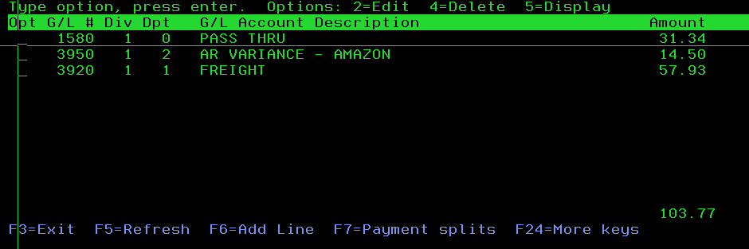
  - F7 to split payment (only use this if more than one payment to pay invoice is needed)
  - F3
- Repeat steps starting at 1f until all the A/P is entered.
- F9 to print and check your report

Recurring Entries
This procedure displays the recurring entries AP encounters month after month outlining the steps it takes to manage these entries.

** Posing Previously Set-Up Recurring Entries **
- Every Monday post recurring entry for the custodian, Susan Hall V# 414 in MaddenCo.
  - MaddenCo.
  - 2. Accounts Payable, ENTER
  - 2. Invoice Input, ENTER
  - 1. Input Vendor Invoices, ENTER
  - Store 1, ENTER
  - F11
  - Choose group 2, by putting a 1 on the line, ENTER

- At the beginning of each month post recurring entry for rent & tolls in MaddenCo.
  - MaddenCo.
  - 2. Accounts Payable, ENTER
  - 2. Invoice Input, ENTER
  - 1. Input Vendor Invoices, ENTER
  - Store 1, ENTER
  - F11
  - Choose group 1, by putting a 1 on the line, ENTER

** Update Recurring Entries **

- Pull all ACH forms from file cabinet for respective vendor
- Update and print new ACH forms to file
  - F:\Accounts Payable\Shared\Forms\Recurring Entries
- Update MaddenCo recurring entry
  - MaddenCo
  - 2. Accounts Payable, ENTER
  - 1. Maintenance Menu, ENTER
  - 4. Recurring Invoices Maintenance, ENTER
  - Store 1, ENTER
  - Find correct recurring entry – 2 to edit, ENTER
  - Update amount to pay, ENTER
  - F6 to add GL
    - Enter amount and GL
    - Ensure updated ACH form and MaddenCo match
- If recurring entries have already been posted for the month and an amount needs added, manually post it in MaddenCo.
  - 2. Accounts Payable, ENTER
  - 2. Invoice Input, ENTER
  - 1. Input Vendor Invoices, ENTER
  - Location 1, ENTER
  - F6
  - Vendor #
  - Invoice Number
  - Date
  - Enter
  - Amount
  - Due date (when others are due, typically 1st of month)
  - Enter
  - Amount and GL to post to
  - Enter
  - F3

** Create New Recurring Entries **

- MaddenCo
  - 2. Accounts Payable, ENTER
  - 1. Maintenance Menu, ENTER
  - 4. Vendor Maintenance, ENTER
  - Location 1, ENTER
  - F6 – Add Invoice
  - Vendor #
  - Invoice Number (this will appear each month, MaddenCo will automatically add date).
  - Enter
  - Group Code = F4 (you can choose to add to current recurring entry (below) or create a new one, just type it in)
    - 1 is Monthly Recurring
    - 2 is Weekly Recurring
  - Amount
  - Description
  - Enter
  - Amount and GL
  - Enter

Mickey Thompson Anticipation
K&M Tire is entitled to an anticipation discount of .75%, calculated at a daily rate of .000250 against each invoice amount (gross amount) for the number of days from payment date to due date.
Example: If invoice for $20,000.00 is paid 25 days early, the anticipation is calculated as: 25 x .000250 x $20,000.00 = $125.00
Write anticipation amount on invoice
Anticipations can be entered in MaddenCo as follows:
- 2. Accounts Payable; ENTER
- 2. Invoice Input & Update Menu; ENTER
- 1. Input Vendor Invoices; ENTER
- Store Number will always be 001; ENTER
- Vendor # should be 113
- Created by or last changed by user: your MaddenCo username
- Enter
- F6 to Add Invoice
- Tab- Invoice No.: Enter the appropriate invoice number and add DISC after it
- Invoice Date: Use Today’s Date; ENTER
- Amount: Enter the anticipation amount calculated as a credit amount
- Tab to DUE DATE and Enter today’s date; ENTER
- Amount: Enter the anticipation amount again as a credit amount
- Tab to GL and Enter 4050-1-1; ENTER
- F3
- F3
- Continue starting at step 8 until all anticipation discounts are Entered

Falken Anticipation
K&M Tire is entitled to receive an additional anticipation discount off of the product amount based on the schedule of payments listed below:
Take the 3% discount. (If Falken doesn’t agree, they will charge K&M back) – Write the anticipation discount amount down on invoice
- If invoice is paid within 10 days from Original Date of Invoice, an additional 3% anticipation discount can be taken.
- If invoice is paid within 30 days from Original Date of Invoice, an additional 2% anticipation discount can be taken.
- If invoice is paid within 60 days from Original Date of Invoice, an additional 1% anticipation discount can be taken.

Anticipations can be entered in MaddenCo as follows:
- 2. Accounts Payable; ENTER
- 2. Invoice Input & Update Menu; ENTER
- 1. Input Vendor Invoices; ENTER
- Store Number will always be 001; ENTER
- Vendor # should be 170
- Created by or last changed by user: your MaddenCo username
- Enter
- F6 to Add Invoice
- Tab
- Invoice No.: Enter invoice number and add ANT 3% after it (Invoice # ANT 3%); TAB
- Invoice Date: Use Today’s Date; ENTER
- Amount: Enter the anticipation amount calculated as a credit amount; TAB
- DUE DATE and Enter today’s date; ENTER
- Amount: Enter the anticipation amount again as a credit amount;
- Tab to GL and Enter 4050-1-1; ENTER
- F3
- F3
- Continue starting at step 8 until all anticipation discounts are Entered

Voiding Invoices or Checks-
In the instance of a mistake or lost checks, this procedure was established to ensure corrections are made.

** Voiding an Invoice **
- MaddenCo Co.
  - 2. Accounts Payable; ENTER
  - 2. Invoice Input & Update Menu; ENTER
  - 3. Select Invoices to Void
  - Enter the store number where the invoice was Entered; ENTER
  - Enter Vendor/Invoice number; ENTER
  - Put a 1 on the line beside the invoice(s) to be voided; ENTER
  - F3
  - 4. Update Invoices to Void; ENTER
  - File printed report in folder ‘VOID Updates’

** Voiding a Check **
- Stop payment with Wells Fargo (if necessary)
  - Log onto Wells Fargo: wellsfargo.com
  - Transaction Search – Place Stop Payment
    - *Who can do this?*
      - Staff Accountant
      - Controller
- MaddenCo Co.
  - 2. Accounts Payable; ENTER
  - 2. Invoice Input & Update Menu; ENTER
  - 9. Select Checks to Void, ENTER
  - Enter for all stores
  - Enter Check number to be voided
  - Put a 1 on the line beside the check number; ENTER
  - F3
  - 10. Update checks to void, ENTER
  - Process will take a few minutes, this will remove the check number and information, bur will open the invoice to be paid at a later time, if you wish to remove it from MaddenCo completely, follow voiding an invoice step (above)
- K&M INC (Bank Ledger)
  - F: Accounting/Shared/Bank Ledgers/ K&M Inc/ K&M Inc
  - Description will be voided check, withdraw will be negative check amount, and reference number will be the check number

United Way
Purpose
Employees can opt to donate to the United Way through a payroll deduction. K&M Tire matches employee donations to the United Way. The following procedure will ensure that these donations are accurately processed and submitted.
Step-by-Step Instructions
- Request Contribution Totals
  - Request quarterly contributions from HR at the end of each quarter (Jan, Apr, July, October)
- Update Spreadsheet
  - Update spreadsheet with new figures and print a copy to put with donation forms.
    - F:\Accounts Payable\Shared\Forms\Recurring Entries\United Way\United Way Weekly Deductions.xlsx

- Verify G/L Balance
  - Verify balance matches G/L 2860-1
    - 3. General Ledger, ENTER
    - 3. Inquiry Menu, ENTER
    - 1. Balance Inquiry, ENTER
    - Store = 1, ENTER
    - Put in 2860 1, ENTER
- Complete County/City Forms
  - Complete forms for each county/city
  - F:\Accounts Payable\Shared\Forms\Recurring Entries\United Way
  - Change the Period Ending date and the amount of the Contributions being made.
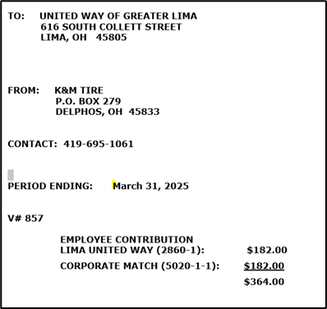
- File and Copy Documentation
  - Copy completed form
    - The original will be mailed with the check as a remittance.
    - The copy will be attached to the spreadsheet completed in step 2a above, for K&M Tire documentation.
    - After entering MaddenCo below, file in the AP invoices to be paid filing cabinet.

- Enter in MaddenCo
  - Enter in MaddenCo by following ‘Entering AP – Invoices’ Procedure
    - Invoice will be period and year in which contributions were collected (example Jan-March 2025)
    - K&M does match donation 100%, post to 5020-1-1

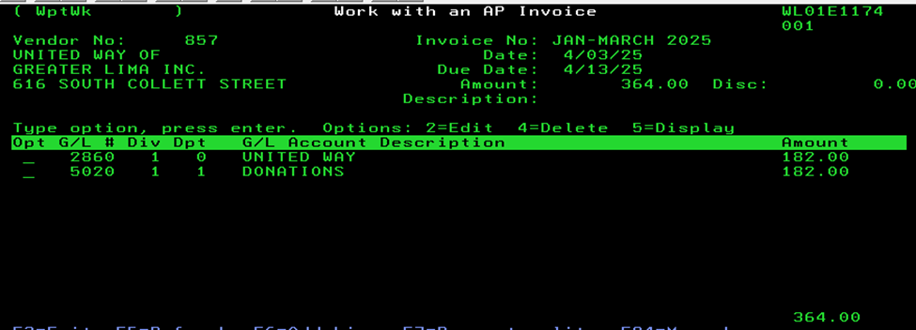

Donations
K&M Tire will donate to causes.

- Verify donations with CEO/President for the upcoming year in late December
  - F:\Accounts Payable\Shared\Lists\Donations.xls
- Once confirmed, copy spreadsheet for every donation that needs made through the year, use these copies as invoices. Highlight each donation separately (one highlighted donation per copy). File in ‘Waiting to Enter’ folder
- On first of every month, check the folder to find donations to be made that month
- Enter into MaddenCo using ‘Entering A/P – Invoices’ Procedure
  - Donation MMYY will be your invoice number

Membership Requests
This section outlines the procedure for handling civic organization membership requests, such as those from a local chamber of commerce, received within the AP Department.
- Receipt of Membership Request:
  - When a chamber of commerce membership request is received, either in physical or digital form, it should be directed to the Admin Manager.
  - Ensure that all relevant details, including the nature of the membership, the associated costs, and any benefits, are included with the request.
- Review by Admin Manager:
  - The Admin Manager will review the membership request as outlined in the approved Admin SOP.
  - The Admin Manager will meet with the President to determine if the membership aligns with the company's policies and objectives.
  - If more information is required, the Admin Manager may contact the requester for clarification.
- Decision Making:
  - Based on the review, the President will decide on whether to approve or deny the membership request.
- Communication with AP Department:
  - The Admin Manager will inform the AP Department of the decision on the membership request.
  - If approved, the AP Department will process the payment according to standard procedures.
  - If denied, the AP Department will not process the payment and will update the records accordingly.
- Responsibilities:
  - The Admin Manager is responsible for reviewing and communicating decisions on membership requests.
  - The AP Department is responsible for processing payments for approved membership requests.

Funds
Additional funds are given to warehouse, ROMs and sales yearly, the following procedure displays how these funds are distributed.
At the beginning of each year, funds will be added as determined by upper management, (funds are only tracked in excel) Send email at the beginning of January for the below.
- Warehouse Fund – email President to see what funds should be added for the upcoming year, have list of part time and full-time employees handy (get this from HR), should be as of Jan 1
- ROM Fund – email President to see what funds should be added for the upcoming year
- Sales – email VP of Sales to see what funds should be added for the upcoming year

Early November, email President to verify Christmas funds to be added to Warehouse fund, have list of part time and full-time employees handy (get this from HR)

** Add Expenses to funds, ex. Business meals, gloves, lunches, etc. throughout the month. **

Warehouse Fund
- Navigate to F:\Accounts Payable\Shared\Lists\Warehouse Fund
  - Select desired tab and track detailed information
  - Alcohol is approved for Christmas parties

ROM Fund
- Navigate to F:\Accounts Payable\Shared\Lists\ROM Expense Fund
  - Select desired tab and track detailed information
  - Alcohol is approved for Christmas parties

Sales Fund
- Navigate to F:\Accounts Payable\Shared\Lists\Sales Expense
  - Select desired tab and track detailed information
  - Alcohol is approved during business meals
Safety Fund
- Navigate to F:Acounts Payable/Shared/Lists/ Safety Expense Fund
  - Track detailed information
  - Track on Warehouse OR ROM Fund as well
    - Add detail to what other funds it was added to

**Email Funds Monthly**

After credit cards have been paid, email funds as listed.

Warehouse – President & VP of Operations
ROM – President & VP of Operations
Sales – VP of Sales & President– each RSM will received their fund
Safety – VP of Operations & President

Balance and Pay by Statement

Goodyear
This procedure displays the steps of paying Goodyear.
Goodyear is due on the 10th of the month. K&M Tire is eligible for an extra anticipation if paid on time. Goodyear is paid electronically through the Goodyear website.

- Select Goodyear’s TireHQ – www.tire-hq.com
- Log in
- Choose “Financial” tab
- Choose “Accounts Payable Details” from list
  - Statement Type = Customer Group
  - Customer # = 000184481
  - Statement Period = Date Range; Enter the From and to dates you require
  - Click View
  - Highlight all of the invoice data and right click to copy.
  - Paste as “TEXT” in Excel
  - Clean up report
- You also need to create a Remittance Worksheet in order to pay online after you have balanced the statement:
  - Log in Goodyear’s TireHQ – www.tire-hq.com
  - Choose “Financial” tab
  - Choose “Accounts Payable Remittance” from list
  - Select a Customer Group = 00184481
  - Click Submit
  - To build “Preliminary Remittance Worksheet, under Quick Select click (one at a time)
    - All Current & Past Due
    - All Future Due Credits
    - All Future Due Debits
  - Under “View Details” click Future Due
  - Deselect all invoices dated next month
  - Click “Save and Return”
  - Click “Queue for Print”
  - Check the tick box for “Goodyear Remittance Worksheet”
  - Check the tick box for “Current & Past Due Items
  - Check the tick box for “Future Due Report Items
  - Click “Submit” (ensure pop-up block is turned off)
  - Click “Print”, a PDF file opens in a new window.
  - Print only the Preliminary Remittance Worksheet
  - Logout of Goodyear’s website
- E-mail the balance due information to K&M Tire’s VP of Finance for payment approval.
- Download list of invoices that have been Entered into MaddenCo for Goodyear
  - 2. Accounts Payable; ENTER
  - 4. Reports Menu; ENTER
  - 8. Outstanding Invoice Report; ENTER
  - ENTER for All Stores
  - ENTER on the next screen
  - Outstanding Date = 123131
  - Print G/L Distribution = N
  - ENTER
  - Select 1 on the next screen for Vendor #
  - Vendor Number = 150
  - Payable Code = 10 (leave 1099 code blank)
  - ENTER
  - TAB to Place report on hold and type Y
  - ENTER
  - ENTER
- Open I-Series Navigator and under Printer Output right click on File Name “Rpotstnr” and Export to Desktop, click SAVE, then delete Rpotstnr from I-Series Navigator and close out of I-Series Navigator.
- Open Rpotstnr in Excel
  - Delete the first 10 rows
  - Sort by vendor first and delete the rows you don’t need at the bottom (which is the header rows of every page that downloaded)
  - Delete the columns you don’t need
  - Format the 3 Amount Columns to Currency
  - Put a formula in the Net Amount column to automatically calculate the Gross Amount minus Discount Amount.
- Compare the amounts from the list of invoices you obtained from the Goodyear website in Step 4 above with the amounts from the list of invoices you created from MaddenCo for accuracy. (VLOOKUP in Excel can be used for this step). Make any necessary corrections in the spreadsheet and in MaddenCo. Note: discounts can be corrected in MaddenCo. If the invoice amount is incorrect, the invoice will need to be voided and re-Entered to correct.
- Once the statement is balanced and the VP of Finance has approved the payment to Goodyear, login to Goodyear’s TireHQ – www.tire-hq.com to electronically submit remittance:
  - Choose “Financial” tab
  - Choose “Accounts Payable Details” from list
  - Select a Customer Group = 00184481
  - Click “Submit”
  - Verify that AP amounts match statement amounts
  - Click “Send Remit to Goodyear”
  - Click OK to the pop-up message
  - Choose “Print” and uncheck all the boxes except Remittance Worksheet.
  - Click “Submit”
  - Click OK to the pop-up message
  - Queue for print
  - Click “Pay Now” – this brings you to the check information page
  - Choose business checking account and Enter K&M Tire’s routing number and account number. Enter your e-mail address and click “I Agree” to the Terms & Conditions. Click “Pay”
  - Print the Confirmation Page
  - Click Finish
  - Close Window
  - From main screen, print Remittance Worksheet (will be e-mailed to you)
  - Logout of Goodyear’s website.
- Once all the invoices that were missing when you balanced the statement (from Step 10 above) have been entered in MaddenCo, a paper check can be ran out. (See “Check Run” procedure *Printing Checks*)
- Advise Accounts Payable and National Accounts that Goodyear has been paid.

Firestone
This procedure displays the steps of paying Firestone invoices.
Firestone is due on the 15th of the month. K&M Tire is eligible for an extra anticipation if paid on time. Firestone is paid electronically by initiating an ACH transfer.
- Select Firestone’s Entirenet – www.bfentirenet.com
- Log in
- Choose “Statement” tab and download the appropriate statement
- E-mail Firestone (WelchKatherine@bfusa.com and RemittanceAR@bfusa.com) a list of invoices you intend to pay by the due date to obtain the anticipation amount.
- E-mail the balance due information to K&M Tire’s VP of Finance for payment approval.
- Download list of invoices that have been Entered into MaddenCo for Firestone
  - 2. Accounts Payable; ENTER
  - 4. Reports Menu; ENTER
  - 8. Outstanding Invoice Report; ENTER
  - ENTER for All Stores
  - ENTER on the next screen
  - Outstanding Date = 123131
  - Print G/L Distribution = N
  - ENTER
  - Select 1 on the next screen for Vendor #
  - Vendor Number = 102
  - Payable Code = 10 (leave 1099 code blank)
  - ENTER
  - TAB to Place report on hold and type Y
  - ENTER
  - ENTER
- Open I-Series Navigator and under Printer Output right click on File Name “Rpotstnr” and Export to Desktop, click SAVE, then delete Rpotstnr from I-Series Navigator and close out of I-Series Navigator.
- Open Rpotstnr in Excel
  - Delete the first 10 rows
  - Sort by vendor first and delete the rows you don’t need at the bottom (which is the header rows of every page that downloaded)
  - Delete the columns you don’t need
  - Format the 3 Amount Columns to Currency
  - Put a formula in the Net Amount column to automatically calculate the Gross Amount minus Discount Amount.
- Compare the amounts from the list of invoices you obtained from the Firestone website in Step 3 above with the amounts from the list of invoices you created from MaddenCo for accuracy. (VLOOKUP in Excel can be used for this step). Make any necessary corrections in the spreadsheet and in MaddenCo. Note: discounts can be corrected in MaddenCo. If the invoice amount is incorrect, the invoice will need to be voided and re-Entered to correct.
- Once the statement is balanced and the VP of Finance has approved the payment to Firestone, fill out an ACH request form and give to the Accounts Payable Supervisor for processing the payment.
- Once all the invoices that were missing when you balanced the statement (from Step 9 above) have been entered in MaddenCo, a paper check can be ran out. (See “Check Run” procedure *Printing Checks*)
- Advise Accounts Payable and National Accounts that Firestone has been paid.

Continental
This procedure displays the steps of paying Continental invoices.
Continental is due on the 20th of the month. Preferred method of payment to Continental is by check.
- Select Continental’s Contilink – www.contilink.com
- Log in
- Choose “Financial” tab and download the most recent statement
- Clean up statement by deleting columns you don’t need, delete heading rows you don’t need, move invoice number to Column A and move due date to Column C
- E-mail the balance due information to K&M Tire’s VP of Finance for payment approval.
- Download list of invoices that have been Entered into MaddenCo for Continental
  - 2. Accounts Payable; ENTER
  - 4. Reports Menu; ENTER
  - 8. Outstanding Invoice Report; ENTER
  - ENTER for All Stores
  - ENTER on the next screen
  - Outstanding Date = 123131
  - Print G/L Distribution = N
  - ENTER
  - Select 1 on the next screen for Vendor #
  - Vendor Number = 141
  - Payable Code = 10 (leave 1099 code blank)
  - ENTER
  - TAB to Place report on hold and type Y
  - ENTER
  - ENTER
- Open I-Series Navigator and under Printer Output right click on File Name “Rpotstnr” and Export to Desktop, click SAVE, then delete Rpotstnr from I-Series Navigator and close out of I-Series Navigator.
- Open Rpotstnr in Excel
  - Delete the first 10 rows
  - Sort by vendor first and delete the rows you don’t need at the bottom (which is the header rows of every page that downloaded)
  - Delete the columns you don’t need
  - Format the 3 Amount Columns to Currency
  - Put a formula in the Net Amount column to automatically calculate the Gross Amount minus Discount Amount.
- Compare the amounts from the list of invoices you obtained from the Continental website in Step 3 above with the amounts from the list of invoices you created from MaddenCo for accuracy. (VLOOKUP in Excel can be used for this step). Make any necessary corrections in the spreadsheet and in MaddenCo. Note: discounts can be corrected in MaddenCo. If the invoice amount is incorrect, the invoice will need to be voided and re-Entered to correct.
- Once the statement is balanced and the VP of Finance has approved the payment to Continental, a check can be run out of MaddenCo (see “Check Run” procedure). Note: Continental has 60-day terms so you do not have to wait for all future due invoices to be Entered before you run a check.
- Advise Accounts Payable and National Accounts that Continental has been paid.

Statement Verification
This procedure explains the process to verify statements.

Vendor statements arrive after the first of the month via e-mail and regular mail. The most frequently used vendors are listed on a spreadsheet F:\Accounts Payable\Shared\Lists\Statement Checklist Corp - 2021.xlsx. This listing will need printed and checked off to ensure all statements have been received. (Some vendors, we only pay by statement, not invoice)
For the Vendors that are paid by statement balance, pull invoices out of the appropriate folder from the AP filing cabinet and verify that all invoices have been received. If invoices are missing, check with AP Receiving Clerks to see if they have the invoices but just have not been received yet or contact the vendor to receive a copy.
- Match the statement balance to the balance in MaddenCo
  - 2. Accounts Payable; ENTER
  - 3. Inquiry Menu; ENTER
  - 2. Vendor Status with Totals; ENTER
  - ENTER for all stores
  - Enter the Vendor number
  - If you do not know the vendor number, Press F4 and type in a few letters of the vendor name and press ENTER, put a 1 on the line by the vendor name you need, and press ENTER
  - Type in a U under Show Only Status; ENTER
  - Verify that the Total Due at the bottom of the screen matches the statement balance.
  - If the totals match, clip the statement to the invoices and set aside to be pulled to pay on the next check run.
  - If the totals do not match, compare the invoice totals from the statement to what was entered in MaddenCo to find the discrepancy.
  - If the invoice amount was entered incorrectly, the invoice will need to be voided and re-entered.
- For all other vendor statements, verify that the invoices on the statement have been received.
- Mass Mutual – Statements to HR
  - 2. Accounts Payable; ENTER
  - 3. Inquiry Menu; ENTER
  - 2. Vendor Status with Totals; ENTER
  - ENTER for all stores
  - Enter the Vendor number
  - If you do not know the vendor number, Press F4 and type in a few letters of the vendor name and press ENTER, put a 1 on the line by the vendor name you need, and press ENTER
  - TAB down to Invoice and type in the invoice number to locate and ENTER
  - Verify the amount Entered matches the invoice total off the statement
    - ATG – check invoices without the V
  - Repeat step f until all invoices on the statement have been verified.
  - If invoices are missing, check with AP Receiving Clerks or National Account Supervisor to see if they have the invoices but just have not been entered into MaddenCo; otherwise, contact the vendor to obtain invoice copies that are missing.
    - Online Access Username & Passwords are located at F:\Accounts Payable\Shared\Lists\Vendor Logins & Contacts.xlsx
    - Battery Systems – if missing invoices contact Batteries & Accessory Specialists.
    - Kriete, Mainline, Mainline Truck, Rush V#817 - if missing invoices on statement, log into interstate billing.com and print invoices copies for approval
  - All missing invoices will need approval and Entered into MaddenCo
  - Once the entire statement has been verified, the statement can be dated, initialed, and filed by vendor name.

Payments

Setting up a Vendor ACH Payment through MaddenCo

- MaddenCo
  - 2. Accounts Payable
  - 3. Inquiry Menu
  - 2. Vendor Status with Totals
  - Enter for all Stores
  - F4 to search for vendor name
  - 2. To Edit Vendor
  - Change Payable # to 20
  - Enter
  - 2. To Edit Vendor
  - F7=Payment Info
    - Vendor Type = V (Vendor)
    - Payment Type = ACH
    - Add Bank Routing #
    - Add Bank Account #
    - Add Bank Type (Hit F4 for options)
      - Select Savings or Checking
    - Send Remittance (Hit F4 for options)
      - Enter E for Email
        - Enter email address when prompted
      - Enter P for Print
      - Enter B for Both Email & Print
    - Enter
  - To add an e-mail address, follow steps 1a-1f above:
    - F12 twice,
    - Shift F6
    - F6
    - Add the email address
    - Name is optional
    - Document to send to this address = ADAP
    - Send document as A = Attachment
- For Employees who want to be reimbursed by Direct Deposit for personal expenses, the employee must complete the Electronic Payment Authorization Form (F:\Accounts Payable\Shared\Concur\Direct Deposit-Authorization Form- EE Reimbursement – Fillable).

  - If they provide you with the bank account number and bank routing number, enter the information in Maddenco by following steps 1a-1j above.
  - If they choose the same account as their payroll deposits, send an e-mail to HR (Marrae Prowant) for the bank routing number and full account number. Validate the information by filling in the last 4 digits of the account number HR provided and initial the Authorization Form. Enter the information in Maddenco by following steps 1a-1j above. Remittance e-mail is not necessary.

Check Run
This procedure explains how AP performs a check run.

- MaddenCo
  - 2. Accounts Payable
  - 2. Invoice Input & Update Menu
  - 5. Select Invoices to be Paid
  - Store to be used – 000 (All stores)
- F6 to Select Due Date
  - Due date will be a week from the upcoming Sunday
  - Vendor No, leave blank
  - Payables Code = 10
  - Enter
  - F3 to exit
  - F7 to view items selected
- Remove everything from the exceptions list
  - View ‘Check Run – Exceptions’ procedure
    - Enter Vendor under ‘Show only’
    - F11 to remove all invoices
- F9 and print entire listing on Blue Bar
  - These will print in vendor order
- Send total check run amount, and ACH’s to VP of Finances
- Work through report by pulling unpaid invoices (filed) by vendor and matching the invoice number and amount.
  - Build a pile of invoices in the order of the report listing (keep together with paperclip)
  - If vendor has a credit balance
    - Remove credits from vendor until a debit balance is available
      - Take discount into consideration
    - Always pay invoices that receive discounts
    - Remove entire vendor from payment
      - If old, will need to contact vendor for payment for credit
    - (We don’t want to pay a small vendor, if they owe us money)
  - Type ‘4’ on lines that need to be removed from listing (will not pay)
- F9 to print entire listing again
  - Work through the listing a second time to ensure each vendor should be paid and have a debit balance

*Printing Checks*
1. Tire Dealer
  - 2. Accounts Payable
  - 2. Invoice Input & Update Menu
  - 6. Update Invoices to be Paid
  - Enter starting check number (before hitting Enter, load tray 1 with very large stack of checks)
  - Enter
  - Did checks print correctly? = Y
  - Remove checks as soon as they finish printing
- Check Remittance are automatically generated, but do not automatically print
  - ESC
  - 1 next to ‘work with printer status’
  - 8 next to ‘P273K0Z1’
  - 3 next to AP 8x11, Enter
  - F5 to refresh
  - Shift F6 to move to bottom of list
  - 2 next to AP 8x11
    - Change printer to PKONICA4
    - Change number of copies to be printed to 2
    - Enter
  - F3
  - 8 next to ‘PKONICA4’
  - Shift F6
  - 6 next to AP 8x11, Enter
  - F3
  - 8 next to ‘P273K0Z1’
  - 7 next to line that has MSGW in Status Column
  - I
  - Enter twice
- Add to K&M Inc
    - Accounting/Shared/BankLedgers/K&M Inc./K&M Inc.
  - On tab ‘Wells Fargo – Main’
    - Enter description as ‘AP Checks’
    - Total amount of checks in ‘withdrawal’ column
    - Reference number will be the check range, (first check ran – last check ran)
      - If spreadsheet is unavailable email the Accounting clerk the above details and they will enter it into K&M Inc.
- Upload checks to bank on intranet
  - AP – Positive Pay
  - Send to Bank
- Stamp all checks
- Copy
- Tear off bottom stub of the checks and discard
- Staple the copied check with the invoice copy(s)
  - Give to the President in black folder/binder
    - Include current bank ledger balance, and LOC balance (not available balance).
  - If there are tons of invoices, staple copied check and remittance and give to the President, the invoices can be stapled with handwritten date (check date) and put-on file cabinet for future filing
- Put check in envelope with any stubs and make below piles
  - Regular mail
  - Canada / International
    - Flo-Pro, Martins Industries
  - K&M employees
    - View ‘Check Run – Employee Mail List’ procedure
    - If not on ‘mail list’ send via transfer truck
    - Hand out corporate employee checks
  - Staff Accountant– Put in supply closet

Check Run Exceptions List
This procedure explains who AP performs a check run in the event where an exception needs to be made.
- Unselect vendors we pay off statement if statement and invoices have not been matched
  - If statement vendors are ready for payment the Accounts Payable Clerk has these sitting out on their desk.
    - View the ‘Statement Checklist Corp Listing’ for vendors to remove
      - F: Accounts Payable/ Shared/ Lists/ Statement Checklist Corp paying Vendors

Remove Every Time:
141 Continental/General (Monthly, separate)
102 Firestone (Monthly, separate)
150 Goodyear (Monthly, separate)
130 Cooper (ACH)
165 Kumho (ACH)
858 Tribune Trucking (ACH)
1125 Tribune (ACH)
120 Michelin – (Online Payment)
230 CMA (ACH)
966 First Financial Bank (Online Payment)

Anticipation: Remove if anticipation has not been calculated (Anticipation is typically calculated on Tuesday or Friday Morning)
113 Mickey Thompson – (post mark)
170 Falken – (post mark)

Other:
2691 Lee’s Tire - insurance and property tax is for Lisbon Falls location, pay only when rent is paid, rent is paid to V# 2692
162 Yokohama – pay when due (15th & 25th), but must calculate 3% discount ahead of time (typically run separate check)

Check Run – Employee Mail List
Refer to Outside Sales and ROM’s list as provided by Human Resources.

Check Run Timeframes
Purpose: The purpose of this SOP is to establish clear and consistent timeframes for the submission, approval, and processing of check runs, including payments made via check, wire, and ACH transactions.
- Check Run Days:
- Check Runs are performed on Monday, Wednesday, and Friday each week.
- An exception occurs for federal and bank holidays. We do not process check runs on bank holidays but rather pull ahead due invoices on the preceding check run.
- Submission of Check Run (Accounts Payable Team):
- The Accounts Payable team will prepare the check run by compiling all invoices, payment requests, and supporting documentation.
- The check run (including wire transfers and ACH payments) should be submitted to the Accounts Payable Manager by 10:00 AM on the day of the check run to allow for review and approval.
- The Accounts Payable team must provide clear instructions regarding the payees, amounts, and any special payment instructions, including bank account details for wire or ACH payments.
- Approval of Check Run (Accounts Payable Manager):
- The Accounts Payable Manager will review and approve the submitted check run by 11:00 AM.
- In the event the Accounts Payable Manager is unavailable, the following hierarchy will be followed for approval:
    - Director of Finance
    - Controller
    - EVP
    - President
- The approval process includes confirming the accuracy of amounts, verifying the legitimacy of supporting documentation, and ensuring compliance with company policies.
- If new or updated Wire or ACH instructions were provided by any vendor, the approver will verify accuracy and authenticate using a known phone number for vendor.
- If the approval process identifies discrepancies or missing information, the approver will request clarification or additional details from the Accounts Payable team.
- The approval process includes verifying bank balances and the total of outstanding checks against the current check run to ensure sufficient funds are available.
- Use the daily banking balances provided by Accounting to estimate the balance after processing the check run.
      - Example (w/current bank accounts)
- If the “Estimated LOC Available” balance after “Today’s Payments” falls below $15 million, AP Manager or subsequent approver will forward check run to the EVP for a second approval.
- Once reviewed and all concerns addressed, the approver(s) will provide formal approval to proceed with the payment.
- Processing of Check Run:

  - For Checks: Once the check run is approved, the Accounts Payable team will process the checks by 2:00 PM, including printing, signing, and preparing them for distribution.
  - For Wire Transfers and ACH Payments: Once the check run is approved, the Accounts Payable team will initiate wire transfers and process ACH payments by 3:00 PM. ACH payments must be completed by 3:00 PM (Same Day ACH deadline with PNC). Wire transfers must be initiated by 6:42 PM and approved by 6:44 PM for the same day delivery.
- Summary of Daily Processing Times
Task | Standard Timeframe | Description
Check Run Submission (Accounts Payable Team) | By 10:00 AM on the day of the check run. | The Accounts Payable team prepares the check run, ensuring all documentation is in order and submitted for approval by 10:00 AM.
Check Run Approval | By 11:00 AM | The Accounts Payable Manager reviews and approves the check run. If unavailable, the next available approver in the hierarchy will approve.
Processing of Check Run | By 2:00 PM | Once approved, the Accounts Payable team processes the check run, including printing checks and preparing them for distribution.
Processing and Approval of Wire Transfers and ACH Payments | By 3:00 PM | ACH payments must be processed by 3:00 PM (Same Day ACH deadline with PNC). Wire transfers must be initiated by 6:42 PM and approved by 6:44 PM.

6. Exceptions
- Emergency situations or unanticipated delays may result in adjustments to the timeframe, but these should be communicated promptly to all parties involved.

File Paid Invoices
Purpose: This procedure reveals the order in which the paid invoices are to be filed.

- File check copies and invoices received back from the President.
  - File by Vendor Name, bigger vendors will have their own drawer, if vendor doesn’t have own folder, file in MISC drawer by GL number.
    - Always file to the back of folder.
- If folder needs created print label and add folder in alphabetical order.
- Also add to spreadsheet (for end of year printing of new folders)
  - F: Accounts Payable/Shared/Labels/Ap_File Drawers
    - Add on ‘AP Paid’ tab, but in alphabetical order and add if folder should be Small, Medium, or Large

Michelin Payment
This procedure displays the steps of paying Michelin.

- Log into the Website: https://www.michelinb2b.com/wps/portal
  - Donna.burgei@kmtire.com
  - Michelin
- Ebusiness
  - View Your Statement

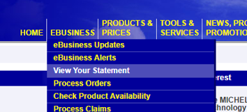

- Double click ‘View Statement Details’ (list on left)
  - Display 100 results (invoices)

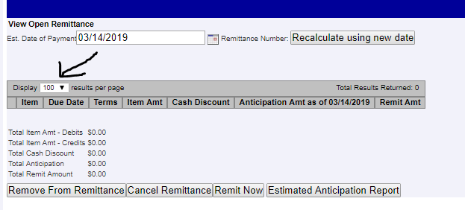
- Right Click on Mouse to print list, (maybe more than 1 page) pull invoices from file cabinet and match to the list, highlight all invoices Entered into MaddenCo. If there are invoices that are missing, check with the team to ensure we have invoices on hand, if not print invoice by clicking invoice number and printing. (ensure to give to team member to get Entered)
- Check box to select all invoices
- Add to Remittance (ensure total is not a credit balance)
- View Open Remittance - Display 100 invoices and Print (If Michelin has not cleared the previous weeks invoices, it will show up at the top with a Status of ‘REM-PROC’) You only need to print the information after ‘View Open Remittance’

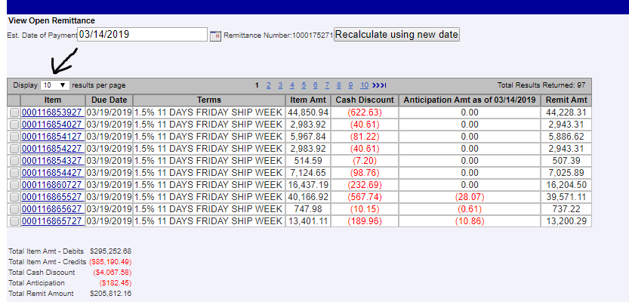

- Remit Now
- Pay Remittance
- E-Check
- Pay Now
- Print (Payment Receipt)
- Click ‘Return to View Pay Remittances’
- Ensure status shows as ‘pay-sent’
- Log-out
- Enter Anticipation amount from remittance into MaddenCo
  - 2. Accounts Payable
  - 2. Invoice Input & Update Menu
  - 1. Input Vendor Invoices
  - Location 1
  - Vendor 120
  - F6 – Add Invoice
  - Invoice Number: ANTICIPATN MMDD
  - Invoice Date: current date
  - Enter
  - Amount: (Anticipation from Michelin as credit)
  - Due Date: current date
  - Enter
  - ‘Amount’ is Anticipation Amount as credit
  - GL# 4050-1-1
  - F3
  - F3
- Add to K&M Inc.
  - F: Accounting/Shared/Bank Ledgers/K&M Inc./K&M Inc.
    - Enter Description as Michelin ACH
    - Enter amount from Michelin (Total Remit Amount)
    - Enter check number (MMDDYY next numerical number for the day)
- Wait to run invoices out of MaddenCo until all invoices have been received
  - Write on post-it notes the Total paid and check number
  - Highlight all invoice numbers on remit of invoice copies received (periodically check the Michelin folder until all invoices are received)
- After all invoices are received, run out of MaddenCo by using the check number as determined above, and confirming with the total amount as determined above.
  - Refer to Check Run Procedure
- Staple everything together (Check, Remit, and Invoices) and file

Yokohama
This procedure displays the steps of paying Yokohama.
K&M Tire is eligible for a 3% discount. Credits must be deducted prior to calculating cash discount.
- MaddenCo
  - 2. Accounts Payable; ENTER
  - 2. Invoice Input & Update Menu; ETNER
  - 5. Select Invoices to be Paid; ENTER
  - Store to be used – 000 (All stores); ENTER
- F6 to Select Due Date
  - The due date will be 15th or 25th of the current month (depending on what day you are paying to)
  - Vendor No 162
  - Payables Code = 10; ENTER
  - F3 to exit
  - F7 to view selected items
- F9 and print the report on Blue Bar
- Working through the report, pull each unpaid invoice and verify that the invoice number and amount match the report total.
- Once you have pulled all unpaid invoices and verified, calculate the discount at 3% of the total amount due.
- Enter the discount in MaddenCo:
  - 2. Accounts Payable; ENTER
  - 2. Invoice Input & Update Menu; ENTER
  - 1. Input Vendor Invoices; ENTER
  - Store Number will always be 001; ENTER
  - F6 to Add Invoice
  - Vendor No. is 162
  - Invoice No.: ANTICIPATN MMDD
  - Invoice Date: Use Today’s Date; ENTER
  - Amount: Enter the 3% that was calculated in Step 5 as a credit amount
  - Tab to DUE DATE and Enter today’s date
  - ENTER
  - Amount: Enter the 3% that was calculated in Step 5 as a credit amount
  - Tab to GL and Enter 4050-1-1; ENTER
  - F3
  - F3
- Perform an Accounts Payable Update by following ‘AP Update Procedure’ or let system update overnight
- After the update select the discount, you entered and all due invoices and follow ‘Check Run’ Procedure.
- Email excel remit (manual process, iSeries, export with excel, open in excel, reformat) to Beverly.canaday@yokohamatire.com

First Financial Online Payment
Purpose: K&M’s corporate credit card that is used by the team across all of the locations to purchase supplies and other items is with First Financial. We pay the card balance in full each month. This procedure explains how to make an online payment for First Financial. The payment can be made by the AP Manager or AP Team Lead

- Go to: https://www.ezbusinesscardmanagement.com
  - Select Make a Payment under Quick Links View
  - Click on “BL Acct 00006030-10000000
    - Once selected a check mark will appear
  - Select Make a Payment
  - Use the drop down to select Payment Amount – select ‘Statement Balance’
  - Select Date to Make Payment
    - 20th of month or closest business day
    - The due date is on or around the 27th, however paying on the 20th avoids exceeding our credit limit of 450,000
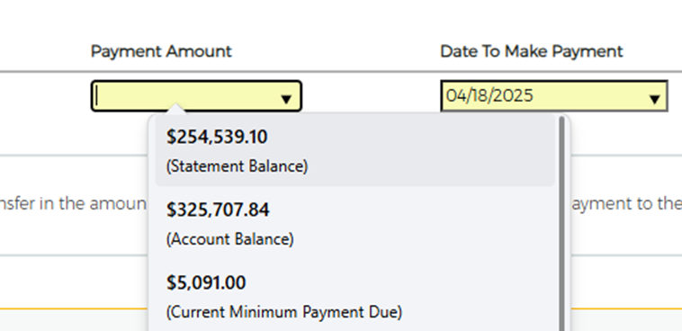
  - Select Pay
  - An email will be sent to the email address in Email Confirmation. Save the email in the appropriate monthly folder under F:Accounts Payable/Shared/Concur/YYYY-MM
  - Forward the email to Invoices@KMTire.com & Accounting@KMTire.com
- Once all credit cards have been Entered into MaddenCo, the invoices will be paid out of MaddenCo following Check Run Procedure

Payment should be processed in MaddenCo prior to month end.

BKT & Speedway Wire Transfers
This procedure gives an outline on how to do a wire transfer for BKT and Speedway.
Receive email from purchasing listing the invoices to pay that day with the amounts and Loc #

- Pull invoices from folders (top drawer of file cabinet by Accounts Payable Clerks)
- Verify invoice #/$ amount/location #/add for total for each vendor
- Reply all and add A/P Supervisor, Controller, and Senior Accountant so they can initiate and approve wires
- List vendor (BKT or Speedway) and total amount to be transferred
- Create Journal Entry in MaddenCo
  - 3. General Ledger, ENTER
  - 2. Input & Update Menu, ENTER
  - 1. Work with outstanding JEs, ENTER
  - F6 –Create New JE
  - F2-Get a Reference #
  - Year/Period will be 3 months past current month (example: January 2019 will be 2019/04)
  - ‘Description’ is a quick description as to why the Journal Entry is being made, (BKT Wire, Speedway Wire, etc.,) ENTER

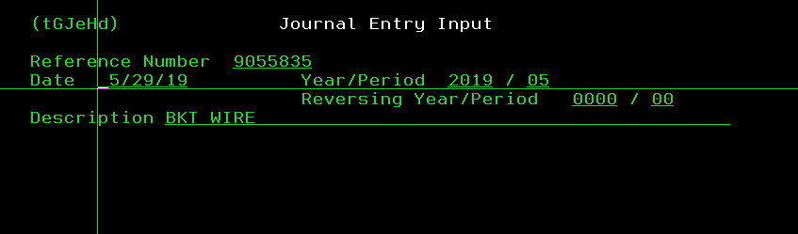
  - Put in GL (1310-location) and amount as Debit, ENTER
  - Credit GL 1010-1 with total amount to be transferred, ENTER
  - Ensure Debit’s and Credit’s equal

Manual Blank Check
Manual Blank checks should only be given out as a last resort and need to be approved by the Accounts Payable Manager, Controller or Director of Finance. The following procedure provides the steps in which a Manual Blank Check would be generated.

- Receive completed check request form
  - F:\Accounts Payable\Public\Check Request\Check Request Form (Non-Employee & K&M Cares).docx
- Complete check as instructed. Make copy for file, staple email/backup to copied check
- Add to 1017-1 Bank Ledger - YYYY.
    - F:\Accounting\Shared\Bank Ledgers\K&M Inc\PNC\PNC AP 1017
    - Enter description as ‘Blank Check to (Payee)’
    - Reference number will be the check number
    - Highlight row (so it stands out)
      - If spreadsheet is unavailable email accounting@kmtire.com to have above details added to 1017-1 Bank Ledger - YYYY.
- Follow up with Requestor until blank check has an amount and invoice backup
  - It is important that the requestor understands check will not clear until they provide us with the Payee & Amount, so we can run through MaddenCo and upload with positive pay file.
  - The check amount and backup should be emailed to the AP Manager for review.
  - Enter amount into 1017-1 Bank Ledger – YYYY
  - Enter the amount into K&M INC
    - F:\Accounting\Shared\Bank Ledgers\K&M Inc\PNC\PNC AP 1017
- Enter invoice(s) into MaddenCo using ‘Entering AP – Invoices’ Procedure
- Update using ‘MaddenCo AP Update’ Procedure
- Run out of MaddenCo using paper check by following ‘Check Run’ Procedure

Initiate ACH-Wire Payment through Wells Fargo
This procedure shows how to initiate ACH-Wire Payment through Wells Fargo.

- https://www.wellsfargo.com/
- Commercial
- Sign On

** ACH **
-These will be received from Accounts Payable department via paper (form)

- Click ‘ACH Payments’
  - Token password (pin and token code)
  - continue
  - Create Payments (left side tool bar)
  - CCD (left side tool bar)
  - Company Entry Description = ‘AP payment’
  - Originating Account: select the only one that populates
  - Put ACH Paper Vendor Forms in Alphabetical Order
  - Click ‘Select’ if ACH vendor is already set up
    - Chose Companies (click all of them you are processing)
    - Click ‘Done’
    - Skip to step 2j
  - Click ‘Create Beneficiary’ if ACH Vendor is NOT set up
    - Complete required field with information provided from Accounts Payable Department
      - Form found at F:\Accounts Payable\Shared\Forms\ACH Transfer Request.xls
    - Options: Save to Beneficiary List (if paying at later date)
    - Continue
  - Add amount for each Beneficiary
  - Make sure totals match
  - Add amount Entered onto the paper form you received, add name and date of transfer
  - Submit
  - Give form to second approver

** WIRE **
-These will be received from Accounts Payable department via email

- Click ‘Wires’
  - Token password (pin and token code)
  - Continue
  - Put in Vendor’s name in Template Name field
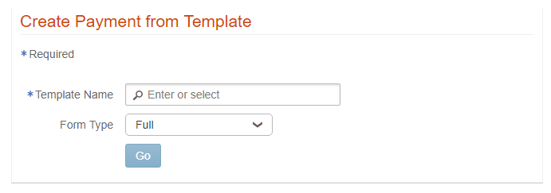
  - Go
  - Enter Amount
  - Submit
  - ‘Reply All’ to email that Wire has been Initiated, waiting for approval

Setup ACH Preauthorization’s
When ACH payments are made, they are not sent through positive pay. Therefore, when the payment clears the bank, it will be sent through for approval. This procedure will allow you to set parameters for vendors so they will not need approval for each payment.

- To set up an ACH Preauthorization:
  - Log in to Wells Fargo
  - Fraud Manager
  - ACH Preauthorization’s
  - Search Past Transactions
    - Add checking account to search
    - Add date range
    - Click Search Button
    - Click on the transaction to add
  - Click on Preauthorize Future Transactions
  - Fill in “company nickname” (something recognizable for the transaction)
  - Must select either the end date, number of occurrences or the company limit
- Click Continue
- To see the list of ACH Pre-authorizations already set up:
  - Fraud Manager
  - ACH Preauthorization’s
  - Click on the blue box “4123346330-K&M Tire Main”
  - Scroll down to see the list
(There are several transactions that are set up that do not have a nickname, so you don’t know what these transactions are for). You can add a nickname by clicking edit on the right)

Month End Processes
This procedure explains how processes are handled for the end of every month.

Balancing GL 1310
This procedure explains how to balance GL 1310. GL 1310 is where we code all items we paid for but have not received the product.

- Go into MaddenCo to print GL report
  - 3. General Ledger, ENTER
  - 4. Reports Menu, ENTER
  - 2. Other Reports, ENTER
  - 1. Audit Report, ENTER
  - 000 All Stores, ENTER
  - ENTER
  - 1, ENTER
  - Run for specific year period, ENTER
  - GL 1310 – 1310, ENTER
- Open GL 1310 Recon Spreadsheet
    - F: Drive/Accounts Payable/Pam Riley
  - Check the ending balancing for each location against the balances on the spreadsheet. (Column D)
    - If they do not balance, find variance and make spreadsheet right
  - Once they all balance, delete the rows for the invoices that have zero balances
  - Print 2 copies of all locations that were verified against the 1310 report (MaddenCo Report) Staple originals together and file in Accounts Payable Clerk desk, staple copies together and give to controller, including 1310 report from MaddenCo

Balancing GL 2320
This procedure explains how to balance GL 2320. GL 2320 is the GL in which all items received are posted. Once the AP side is entered, it clears the 2320. Therefore, all items in 2320 have not been entered for payment.

- MaddenCo
  - 2 - Accounts Payable, ENTER
  - 2 – Invoice Input & Update Menu, ENTER
  - 1 – Input Vendor Invoice, ENTER
  - Go into each location separately and make necessary changes
    - Changes include:
      - Vendor ‘Mighty Tire V# 552’, flip to Vendor ‘Tribune Trucking V# 858’
      - Vendor ‘U.S. Postal Service V# 111’, flip to ‘Hankook V#1110’
  - Do a print screen for all open items in each location separately including equipment locations (48,58,68)
    - Do print screen even if the location has no data
  - Click 1st icon on the toolbar
    - Be sure to page down and do a print screen for any additional items that are not on the first screen (you need a print screen of every item open)
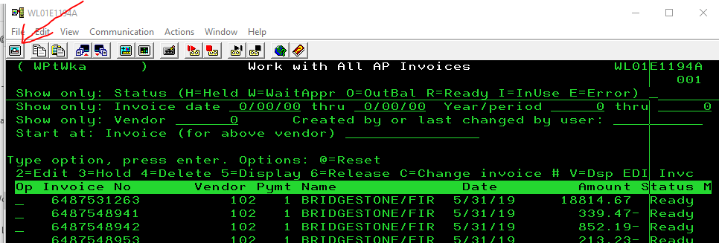

  - Do print screens for each location before continuing on
  - Staple each location together and put in location order
  - When complete, go into each location separately again including equipment locations (48,58,68) and edit each invoice, changing the Year/Period
    - 2. (Edit) on invoice line, ENTER
    - Tab down to ‘Year/period expensed to ___ / __ ‘and change period to next month. Example: 2019/06 would be changed to 2019/07

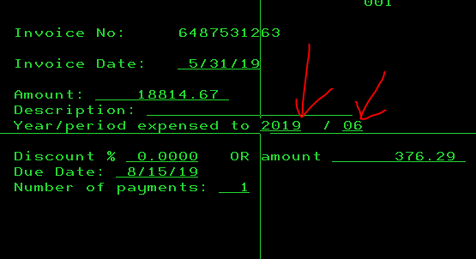

  - Once the dates are changed the Status will change from WtApr (waiting for approval) to the Ready status. Put these on Hold by putting a 3 on each line and hit ENTER
    - They should now say Held under the status column
- Total each Vendor on print screens individually
  - In MaddenCo put Vendor number in the ‘Show Only Vendor’
    - Write down the Vendor and Amount on print screen for each vendor, when done verify the total for each print screen matches the breakout
      - Exception: If ASN (Goodyear, Michelin, or Firestone) for Wise location need only the 2320 amount.
          - Current wise locations 1,6,43,49,51,83
        - Should have made a cheat sheet on last day of month for all wise locations, the total in receiver screen (far right) will be 2320 amount, when it flips from receiving to AP, the variance gets posted to 4080-1-1

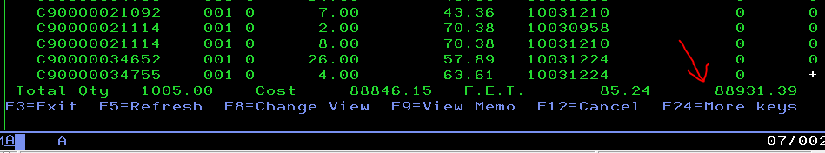
        - If cheat sheet was not created open and view the receiver to see if it was done by ASN. Any receiver that was done by ASN, you must add back amount, the amount will either be added or subtracted from the print screen total and the new amount will be your correct total.
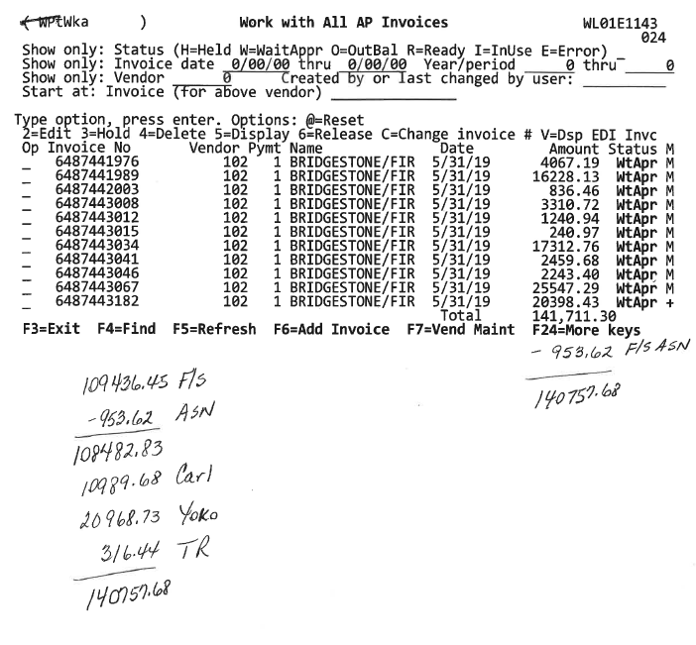

- Verify totals in the GL. Beginning at the start menu in MaddenCo go to:
  - 3 – General Ledger, ENTER
  - 3 – Inquiry Menu, ENTER
  - 1 – Balance Inquiry, ENTER
  - 000 Store Number
  - ‘G/L Account’ put 2320 and the store number to verify
  - Ensure the last line matches your print screen total
    - If it doesn’t balance run G/L report and check for the dollar amount that is off for each location.
      - MaddenCo, 3. General Ledger, 4. Reports Menu, 2. Other Reports, 4. G/L Audit/Trial Balance Report, ENTER, ENTER, 1 ENTER, run for correct period and year, GL 2320
    - If it doesn’t balance you can also look at receivers from 31st
    - If need to make Journal Entry to fix or move amount, typically post to 4050-1-1 follow ‘Creating a Journal Entry in General Ledger’ Procedure
    - Update and verify GL amount
  - Once this is complete, AP Entry is can now be put in
- Log balance and amounts in 2320 Reconciliation Spreadsheet
  - F:\Accounts Payable\Shared\Lists
    - In the top section, put the print screen total in for each location.
    - In the bottom section, put the totals in for each vendor. These totals should match.
  - Print 2 copies of spreadsheet, give one to controller, staple other copy to top of all print screen’s and file to back in top drawer.

Year End Processes

Fiscal Year-end
To ensure the organized transition of check and invoice copies from the current fiscal year to prior year storage and to replenish file folders as needed. This process supports year-end recordkeeping and filing efficiency. The Admin team may assist, pending availability—coordinate with their manager to confirm support.

K&M Tire’s fiscal year-end is September 30th.
- Early August, review the AP File Drawers list to determine how many file folders are needed.
  - Go to F:\Accounts Payable\Shared\Labels\AP_FileDrawers.xls for the list
  - Sort by S-small, M-medium, L-large to determine what is needed
    - Small = Manilla folders
    - Medium = Small Expandable Folders
    - Large = Large Expandable Folders
  - Send count of each to Admin@KMTire.com
- Box up the files that are in the Accounting room from the previous year and take to storage (designated room in Warehouse).
  - Admin team assists with this
- Once everything has been filed for the current fiscal year-end, move the current fiscal year files to the filing cabinets in the Accounting Room
  - Admin team assists with this.
  - Except for tax folders.
    - Tax folders are kept in the storage room across from Logistics near the warehouse entrance.
- Create file folder labels from the list found at F:\Accounts Payable\Shared\Labels\AP_FileDrawers.xls
- Place the labels on the appropriate size file folder.
- File the empty folder in the filing cabinet drawers.
NOTE: Refer to SOP 4.9.11 AP Document Retention for more information on the length of time we retain invoices, purging old files from storage, and which vendors are retained electronically vs paper.

Other

MaddenCo AP Update
This procedure is to update Vendor Invoices in MaddenCo. Invoices cannot be paid until they post to the vendor account in the nightly process. If an invoice needs to be entered and paid in the same day, this process will need to be completed before the payment can be processed.
- Communicate with co-workers (including NAB) to ensure all entries have been reviewed and that it is okay to update.
  - 2. Accounts Payable; ENTER
  - 2. Invoice Input & Update Menu; ENTER
  - 2. Update Vendor Invoices; ENTER
  - Screen populates with today’s date
  - ENTER

Vendor History Lookup
- MaddenCo
  - 2. Accounts Payable, ENTER
  - 3. Inquiry Menu, ENTER
  - 2. Vendor Status with Totals, ENTER
  - Enter (all stores)
  - F4-Find
  - Enter name (filters by sort name)
    - If employee Enter part of last name
  - 1-Select, ENTER
  - You can filter here by Paid, Unpaid, or Both (if blank will look at both), you can Enter year/period-this filtered by calendar year/period or invoice number

Creating Journal Entry in General Ledger
This procedure gives instructions on how to create a journal entry in General Ledger.
- MaddenCo
  - 3. General Ledger, ENTER
  - 2. Input & Update Menu, ENTER
  - 1. Work with outstanding JEs, ENTER
  - F6 –Create New JE
  - F2-Get a Reference #
  - Year/Period will be 3 months past current month (example: January 2019 will be 2019/04)
  - ‘Description’ is a quick description as to why the Journal Entry is being made, ENTER
  - Put in GL and amount, ENTER
    - You can search for GL by clicking F4
  - Ensure Debit’s and Credit’s equal and F3

General Ledger Re-Class (Moves)
Overview: upon review of any General Ledger (GL) entry, if it’s determined that an expense has been posted to an account in error, a Re-class or GL Move will be necessary. These entries should feed through the Controller.
Errors can be found through account balancing or check run review or various methods. Once the error is found, proceed as follows.
- Research entry
- Recurring entry
    - Review past entries to confirm accuracy.
      - Do all entries need moved or just this one?
  - Individual/Miscellaneous entry.
    - Review charges and compare them to GL list of accounts.
    - Confirm correct account with Controller to get approval of move.
      - The controller should initial correct account.
- Make note of re-class required on original document, date & initial.
- Make a copy of the original document to provide to Controller with support to make JE to re-class expense.
- File original document in appropriate file.
- Make any necessary notes to use correct GL for like transactions going forward.

Example:
Andersen Invoice coded to 5050-1.
Copy of invoice with original [incorrect] GL:
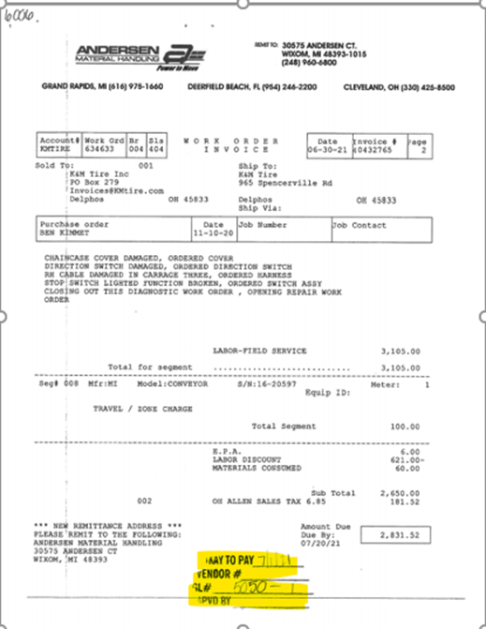
- Reviewed the GL account list and correct account with Controller, provide copy of invoice & check to Tina to record re-class entry.
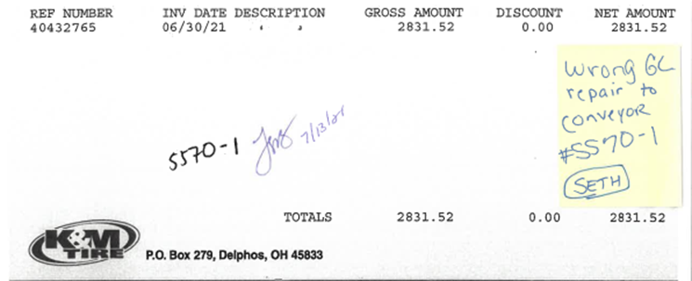

- Make note on check copy that expense has been moved from original GL account to correct GL.
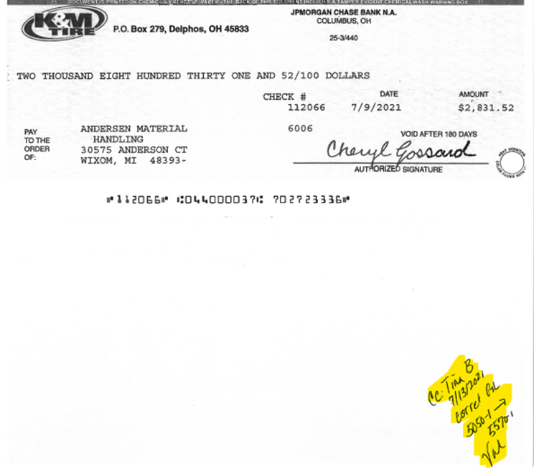

- File original document with closed AP invoices.

AP Invoice Number Inquiry
Purpose: To provide clear instructions for verifying if an invoice has been paid. This process is most often used when a vendor contacts K&M regarding an invoice they show as outstanding in their records.
1. To search by invoice number: (search all vendors)
- Open MaddenCo
- 2 – Accounts Payable
- 3 – Inquiry Menu
- 8 – A/P Invoice Inquiry
- Enter through Enter Store Number (all stores)
- Show only: Status – leave blank, tab to next field
- Enter invoice number
  - If the invoice number is in Maddenco, look at the vendor name & invoice date to select the correct invoice
    - Enter 6 on the correct invoice line to Display Check
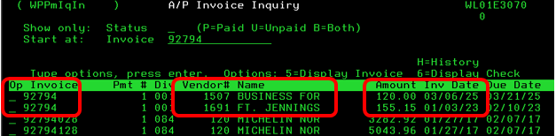
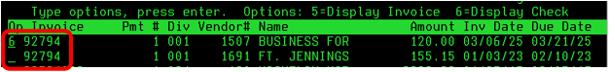
    - This will show check #, check date & other invoices that were paid.
2. Communication with Vendor: (if due to outstanding payment)
- Share payment status, check number, check date, and invoices paid with that payment.
- Ask vendor to see if the other invoices paid by that same check or ACH are open in their system.
  - In this example, only one invoice was on this check.
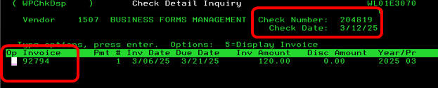
- If the vendor doesn’t have record of receiving the check, research if the check has cleared.
  - Go to Intranet to Accounting, Outstanding Checks Report (AC – Outstanding checks Report)
  - Enter the check number under Search by Check
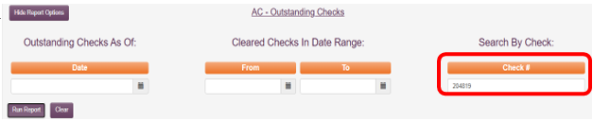
  - If the check has cleared our bank account, you will be able to see the “Date Cleared”
    - Give the date check cleared to the vendor.
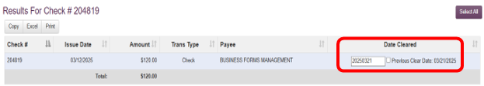

  - If a copy of the cleared check is requested by vendor, log into Pinnacle PNC to download a copy, including both front and back sides.
  - If the check has not cleared the bank, determine if the check needs to be voided and payment reissued to vendor.
    - Due to mailing delays, we typically do not void and reissue unless check is over 4 weeks old.
- If payment was never issued because the invoice number is not in Maddenco, request a copy of the invoice and follow instructions to get approval and process payment.

Lookup Invoices using check number
This procedure explains how to search for a specific check number.
This gives you the ability to view only the items paid for on a specific check number
- MaddenCo
  - 2. Accounts Payable, ENTER
  - 3. Inquiry Menu, ENTER
  - 5. Check Number, ENTER
  - ENTER (all stores)
  - Put in vendor number
    - Search by F4
    - Enter sort name, ENTER
    - 1-select, ENTER
  - Put in check number
    - 5-display invoice
    - 6-display check

Cardholder List Audit & First Financial eZ Card Access
This SOP explains how to pull a list of active cardholders from eZBusiness to verify if any credit card accounts need to be closed, and the procedure for closing them. It also explains how to check if a cardholder is set up in eZCard to pull and view their own statement.
- Log into eZ Business: https://www.ezbusinesscardmanagement.com
  - Select Company Search under Quick Link

  - Select Cardholder icon
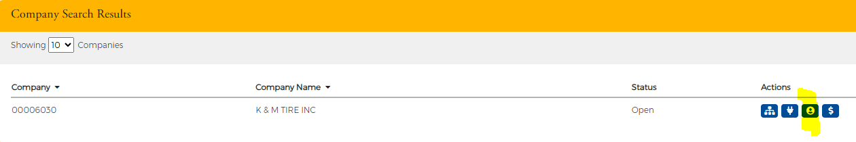
  - Select Export, All Columns, Excel
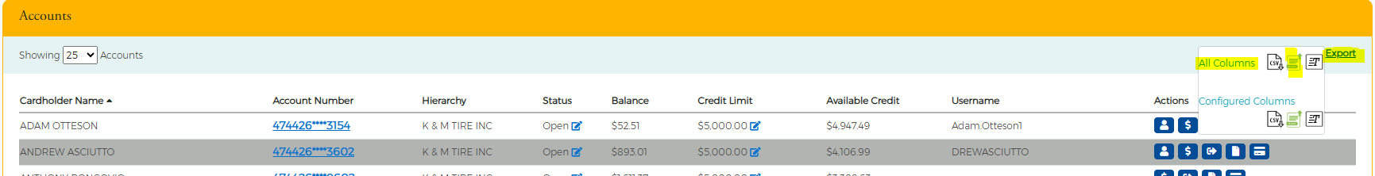
  - Excel report will populate to Download

- Review each cardholder in Column A
  - If an employee is still active & in a role that requires a company credit card no change is needed
  - If an employee is inactive, close their account by following instructions below.

- Closing Cardholder Account
Note: the following steps are to be performed immediately when a cardholder employee is terminated or no longer employed by K&M Tire.
  - Go to Online Requests
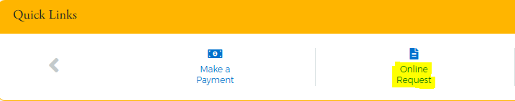
OR
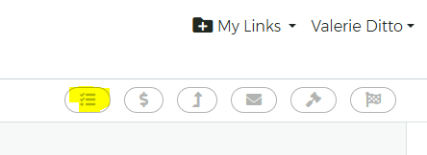
  - Select Close Account Request
  - Enter Cardholder’s Name
  - Click in Reason to select appropriate reason

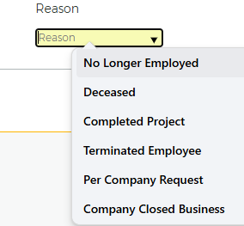
  - Memo – add note “Card turned in” “Card destroyed” “Requested by [First initial, Last Name]”
Note: We ask the former Employee’s manager to destroy the inactive card. Sometimes they will have already mailed it back to AP and we destroy it once received.
- EZCard access for each cardholder can be checked by looking for a Username
  - Search for an appropriate cardholder
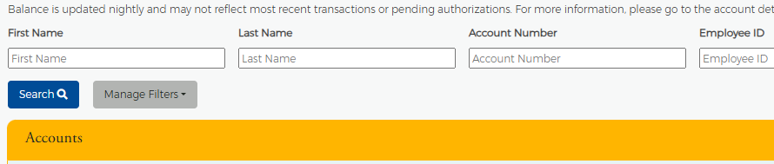

  - If Username is blank, cardholder has not signed up for ezCard
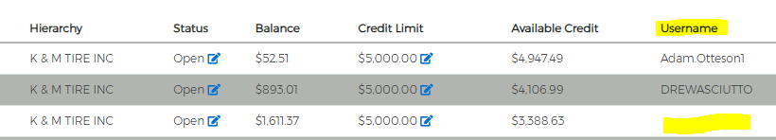
- Instructions for ezCard should be emailed to all cardholders with no username so they can get access to their statement.
1. “EZCard Enrollment Guide – Business Credit Card” can be found under F:\Accounts Payable\Shared\Concur\New User Guides - Welcome Email\New Set Up Attachments to send.

Credit Applications for Vendors
Purpose: This outlines the process when Account Payable receives a credit app which typically come from a warehouse manager or ROM.
- Print credit application form after completed (if fillable) or print to complete.
  - Refer to “Credit Application Information [CY]” in F:\Accounts Payable\Shared\ Forms\Credit Application Information YYYY if needed.
- Do NOT complete any type of “Personal Guarantee” on any application
- AP Manager or Team Lead to stamp President’s signature where required
- Return completed credit application to vendor including the following documents:
  - W9
    - located F:/Accounts Payable/Shared/Forms/W-9
  - Credit Application Information
    - located F:\Accounts Payable\Shared\ Forms\Credit Application Information YYYY

Weekly Inventory Invoice-Receiver Check
Note: the following procedures are done on a weekly basis.

- Review all invoices that are over 7 days old and have not been matched to a receiver.
  - Check Maddenco to verify that receiver hasn’t been overlooked.
  - Contact the WAM & warehouse to see if tires have been received and a receiver is being entered.
  - If tires have not been received after 14 days, contact Purchasing to see if tires are still expected to be delivered.
    - If for some reason tires will not be delivered, request that Purchasing contact the vendor for a credit to offset the invoice for tires not delivered.
  - Make a note on the invoice regarding the status & follow up
- Review all open receivers in Maddenco that are over 7 days old.
  - If receiver doesn’t match an invoice on hand, reach out to the vendor for an invoice.

AP Document Retention
Purpose: The purpose of this SOP is to establish a consistent and organized process for managing Accounts Payable (AP) check copies, invoice filing, and document retention. This procedure ensures compliance with record retention policies, facilitates efficient retrieval of documents, and outlines proper methods for purging and disposing of outdated records.
- Daily AP Check Copies and Invoice Filing:
  - AP check copies are attached to the front of corresponding invoices and filed either by vendor or by GL code (if the vendor is not paid frequently enough to warrant its own folder).
  - Vendors paid more than 5 times a year should have their own folder.
  - Fixed Asset invoices should be copied and placed in the fixed asset folder that is used by General Ledger for updating the depreciation schedule.
  - General Ledger is responsible for saving real estate tax and personal property tax invoices on the F: at the time they approve for payment and send to AP.

- Daily Electronic Filing of Major Vendor Invoices:
  - Invoices from major vendors are saved on the F: drive under the following location: F:\Accounts Payable\Shared\Invoices - Vendor
  - Major vendors invoices saved electronically are Bridgestone, Carlstar, Continental-General, Falken, Goodyear, Hankook, Kumho, Michelin, Nexen, Pirelli, Yokohama,
  - It is no longer necessary to save paper copies of these Major Vendor Invoices.

  - Annual Retention and Purging of AP Files:
PLEASE NOTE: AP files are retained for 7 years and then purged, with the exception of tax-related documents which are required to be kept indefinitely.
  - Revised Vendor Label List: AP provides the Admin team with a revised vendor label list in early September. Admin is responsible for ordering supplies and preparing the files.
  - AP transfers Tax Folders to Tax Room: At the end of each fiscal year, AP pulls the current year’s Tax Folders from the filing cabinets and moves them to the Tax Closet (near Logistics, hall leading to warehouse) to retain them indefinitely.
  - Current Year’s Files to File Room: The current fiscal year’s files are moved from the AP filing cabinets to the file room, replacing the prior fiscal year’s documents.
  - Prior Year’s files from File room to Storage: The prior fiscal year documents are boxed and moved to storage in the former sales office.
  - Purging Old Files from Storage: The oldest year in the storage room is then purged to maintain the 7-year retention cycle. Disposal of files is as follows:
    - Files designated for disposal should be:
      - Placed on pallets stacked 4 boxes high and shrink-wrapped for containment.
      - Arranged for an extra recycle pickup, which incurs an additional fee.
      - Admin is responsible for contacting vendor for extra recycle pickup.
  - Purge Old Files from F: The same 7-year retention policy applies to invoices stored electronically for inventory vendors.
    - Each year, folders containing invoices more than 7 years old should be deleted.

Company Expense Process

Concur – Company Paid Credit Cards
Concur is a third-party program that helps us manage expenses, this procedure shows the steps in how to successfully submit expenses.
- Log into Concur – www.concursolutions.com
- Expense – Process Reports
  - All expenses (Amount Due Employee & Amount Company Paid) will appear, filter by ‘Amount Company Paid’
    - ‘Amount Company Paid’ is charges on their company credit card
  - There should only be one company credit card expense report submitted per person each month. This should always be separated (do not process a charge that has an amount in both ‘Amount Company Paid’ and ‘Amount Due Employee’.) Instead kick it back and have the employee separate the charges into a new report.
  - Process ‘Amount Due Employee’ and ‘Amount Company Paid’ separately.
  - Click on charge and review
    - Breakfast and Lunch is reimbursed 100% up to $10
    - Dinner is reimbursed 100% up to $20
      - Breakfast, Lunch and Dinner must have detailed receipt, alcohol will not be reimbursed
    - Sales Vehicle Expense
      - Separate expense throughout the locations in which the salesperson is allocated to
        - F:\Human Resources\Public\Employee allocations.xls
    - Sales Fund Expense includes business meals and items for customers and is tracked at F:\Accounts Payable\Shared\Lists\Sales Expense (year)
      - Use Organizational Chart and Phone list to determine whose sales expense the charge goes under (RSM’s)
        - F:\Human Resources\Public\Warehouse Locations-Contact Information 2019.docx
    - Warehouse Fund includes meals, supplies, and employee benefits for warehouse employees, tracked at F:\Accounts Payable\Shared\Lists\Warehouse Fund (year)
    - ROM Fund includes meals, supplies, and employee benefits for warehouse employees, tracked at F:\Accounts Payable\Shared\Lists\ROM Expense Fund (year)
    - Alcohol is approved for Christmas parties and sales meetings
    - Warehouse Manager Loc. 86 – HQ route has overnight stays, post to travel
    - Location Allocation
      - Sales – Location in which they are traveling for, if vehicle or meeting expense code based on allocation
      - Warehouse – home location unless traveling to fill in for person
      - ROM’s – location in which they are traveling for, vehicle maintenance/repairs is corporate
      - If someone is traveling to help the warehouse, it will be coded to the warehouse they are helping, if traveling for managers meeting, will be allocated to their home location
  - If you need to send report back to employee, click ‘Send Back to Employee’ and add details as to why you sent it back so they can correct and re-submit
  - If an employee submits a personal charge on their company credit card, the accountant reconciling Concur will send to AR manager to bill employee in the same month charge will be paid.
  - When done – click Approve
- Continue approving reports by starting at step 2D until all items are cleared out
- Administration – Company – Tools
- Payment Manager
- Click ‘Close Now’

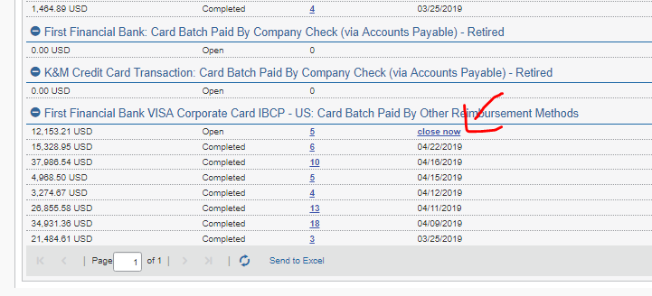
- Download and Save file as F:\Accounts Payable\Shared\Concur (Year-Month)
- Intranet
  - AP – Concur Expense Report – Company Paid
    - Choose file saved in step 6
  - Click ‘Upload Expense Report’
  - Check box ‘Select to Import Select All’
  - OK
    - If items do not upload click ‘Vendor Setup’ in intranet, type in employees name under ‘search for vendor’, type in employees name under ‘concur name’ and click add vendor (you only have to do this if the employee has never submitted report through concur before)
      - Click ‘Import Data’ and choose file saved in step 7
      - Click ‘Upload Expense Report’
      - Import into MaddenCo
      - OK
  - If need to upload more than one file for credit cards, upload both files into intranet (start at step 6 again) before moving onto next step
- MaddenCo
  - 2. Accounts Payable
  - 2. Invoice Input & Update Menu
  - 1. Input Vendor Invoices
  - Store 1
  - Created by or last changed by user: ‘INTRANET2’
    - C online if need to update the date (only do this if import is during the following month, the date should be the month of payment)
    - 2 on each line to review and approve for payment
      - Review the ones with status of waiting approval ‘WtApr’
    - Ensure ‘amount’ is correct
    - ENTER
    - Check to ensure amount is fully allocated
    - F3
    - Double check all names have been transferred from concur into MaddenCo (paper statements)
      - If not start at step 8i to begin troubleshooting
      - If so, add to ‘done’ pile of statements for current month
- Once all credit cards statements have been confirmed, and before the due date, payment online by following the First Financial Online Payment Procedure

- Once all credit cards have been Entered into MaddenCo, pay invoices out of MaddenCo by following Check Run Procedure

  - If past the end of the month, send email with amount to person doing the bank rec

- After it is ran out of MaddenCo, send all ‘Funds’ via email by following Funds Procedure

Concur – Cash Reimbursement
Concur is also used for reimbursements, this procedure explains how to concur users submit their expenses in order to receive a reimbursement.

- Log into Concur – www.concursolutions.com
- Expense – Process Reports
  - All expenses (Amount Due Employee & Amount Company Paid) will appear, filter by ‘Amount Due Employee’
    - ‘Amount due employee’ is an expense report, payable directly to the person who submitted it
  - There should only be one expense report submitted per person each month. This should always be separated (do not process a charge that has an amount in both ‘Amount Company Paid’ and ‘Amount Due Employee’.) Instead kick it back and have the employee separate the charges into a new report
  - Process ‘Amount Due Employee’ and ‘Amount Company Paid’ separately.
  - Click on charge and review (Write down name and amount for later check and balance)
    - Breakfast and Lunch is reimbursed 100% up to $10
    - Dinner is reimbursed 100% up to $20
      - Breakfast, Lunch and Dinner must have detailed receipt, alcohol will not be reimbursed
    - Sales Vehicle Expense
      - Separate expense throughout the locations in which the salesperson is allocated to
        - F:\Human Resources\Public\Employee allocations.xls
    - Sales Fund Expense includes business meals and items for customers and is tracked at F:\Accounts Payable\Shared\Lists\Sales Expense (Year)
      - Use Organizational Chart and Phone list to determine whose sales expense the charge goes under (RSM’s)
        - F:\Human Resources\Public\Warehouse Locations-Contact Information 2019.docx
    - Warehouse Fund includes meals, supplies, and employee benefits for warehouse employees, tracked at F:\Accounts Payable\Shared\Lists\Warehouse Fund (Year)
    - ROM Fund includes meals, supplies, and employee benefits for warehouse employees, tracked at F:\Accounts Payable\Shared\Lists\ROM Expense Fund (Year)
    - Alcohol is approved for Christmas parties and sales meetings
    - Location Allocation
      - Sales – Location in which they are traveling for, if vehicle or meeting
Expense code based on allocation
      - Warehouse – home location unless traveling to fill in for person
      - ROM’s – location in which they are traveling for, vehicle maintenance/repairs is corporate
      - If someone is traveling to help the warehouse, it will be coded to the warehouse they are helping, if traveling for managers meeting, will be allocated to their home location
  - If you need to send report back to employee, click ‘Send Back to Employee’ and add details as to why you sent it back so they can correct and re-submit
  - When done – click Approve
- Continue approving reports by starting at step 2D until all items are cleared out
- Administration – Company – Tools
- Payment Manager
- Click ‘Close Now’

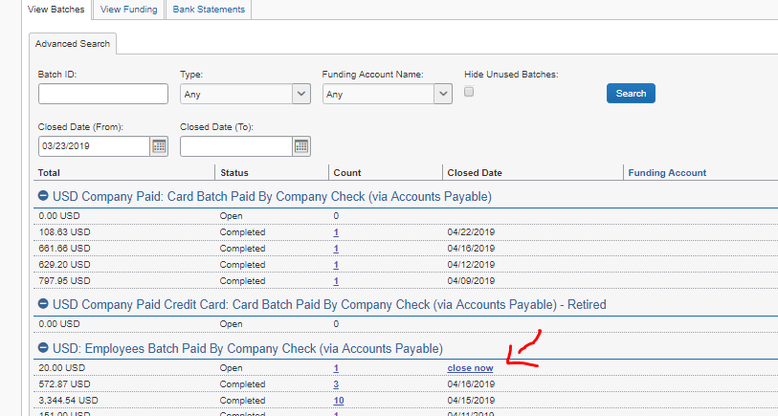
- Download and Save file as F:\Accounts Payable\Shared\Concur (Year – Month)
- Intranet
  - AP – Concur Expense Report – Import Cash
    - Choose file saved in step 7
  - Click ‘Upload Expense Report’
  - Import into MaddenCo
    - If items do not upload click ‘Vendor Setup’ in intranet, type in employees name under ‘search for vendor’, type in employees name under ‘concur name’ and click add vendor (you only have to do this if the employee has never submitted report through concur before)
      - Click ‘Import Data’ and choose file saved in step 7
      - Click ‘Upload Expense Report’
      - Import into MaddenCo
      - OK
- MaddenCo
  - 2. Accounts Payable; ENTER
  - 2. Invoice Input & Update Menu; ENTER
  - 1. Input Vendor Invoices; ENTER
  - Store 001; ENTER
  - Created by or last changed by user: INTRANET2
    - 2 on each line to review and approve for payment
      - Review the ones with status of waiting approval
    - Ensure ‘amount’ is correct
    - ENTER
    - Check to ensure amount is fully allocated
    - Double check all names have been transferred from concur into MaddenCo (paper list) and the amounts are the same
If not start at step 8i to begin troubleshooting

Concur – Hide/Unhide Transactions
This procedure provides instructions on how to hide and unhide transactions in concur.

*Hide old transaction history from user
1. Log into concur at concursolutions.com
2. Administration – Company – Tools
3. Company Card
4. Manage Transactions
5. Enter first name of employee in ‘Contains’ Box
6. Show only should say ‘Unassigned to Report’
7. Search
8. Select rows to be hidden from user
9. Click ‘Hide Selected rows’

*Unhide old transaction history from user
1. Log into concur at concursolutions.com
2. Administration – Company – Tools
3. Company Card
4. Manage Transactions
5. Enter first name of employee in ‘Contains’ Box
6. Show only should say ‘Any Hidden’
7. Search
8. Select rows to be unhidden from user
9. Click ‘Release Selected Rows’

Company Credit Card Audit

Create Credit Card Audit List
This procedure is to ensure all cardholder expense reports are being audited at least annually.
- Pull a list of current cardholders from ezBusiness to compare to the current audit list – F:\Accounts Payable\Shared\Concur\CC Audit\CC Audit List FY 2023
- Remove cardholders who are no longer with K&M or no longer have a credit card.
- Remove cardholders that are highlighted – but first review how many times they are on the list.
- Leave them on the last month they were audited and remove them from prior months.
- Add any new cardholders at the top of the list.
- To assign cardholders the month to be audited simply divide the total number of cardholders by 12 months and count off the first 10 or 12 (whatever the # should be based on total cardholders) on the list and assign to the first month and so on.
- The cardholders per month will shift as cardholders are audited a 2nd or 3rd time due to findings and new cardholders are added.
- Once an audit is complete, anyone with a finding is audited again the following month. A repeat audit is done in the following consecutive months until there are no findings.
- Add the cardholder with a finding on the next month and highlight their name – this will allow you to remove duplicate cardholders when assigning the audit list for the next year.
- Once the year is complete, the audit cycle can start again.

Company Credit Card Audit
Review the selection of cardholders to be audited under F:Accounts Payable: Shared: Concur: CC Audit: CC Audit List FY2023
- Pull list of expenses through Concur
  - Go to Analysis under Reporting
    - From the left side menu, select Team Content
    - Select Analysis – Standard Reports
    - Select Expense Processing
    - Select Expense Entry Analysis Details (grouped by Employee)
    - Date Range
      - Select first day of prior month to last day of prior month
    - Click on Select all for Expense Type (under box showing all expense types)
    - In Keywords type the last name of each cardholder that you want to select
    - Select the correct cardholder from results and move to Choice by clicking insert
      - All employees can be moved to Choice, then 1 report can be run
    - After all cardholders are in the Choice box, click Finish (lower, right of screen)
    - Once Expense Entry Analysis Details (Grouped by Employee) populates, click the “play” button

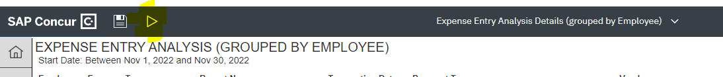

      - Select Run Excel data
      - Open excel report and save as CC Transactions – [month] Audit
- Sort report and add columns
  - Sort report by Payment Type – this removes expenses submitted for reimbursement since focus is company credit card usage (sort Z-A)
    - First Financial Bank VISA = company credit card
    - Cash = expense for reimbursement
  - Add columns
    - Expense Type
      - Enter OK once expense type (column B) is validated for specific charges on receipt
    - Receipt Attached & Viewed
      - Enter Y, N or Affidavit as appropriate
    - Amount/Vendor
      - Add note if Amount or Vendor does not match from receipt to credit card charge on Expense Entry Analysis Details (grouped by Employee) report
    - Policy/Meals etc
      - Add finding here- note if policy is not followed and how/why
- Go to Concur to access cardholder support for transaction
- Under Profile, enter the cardholder’s name under Acting as other user
- Click Start Session
- Open Reports
- Active Reports
- Last 90 days
- Select appropriate report by report name and amount (match to Expense Entry Analysis Details report)
- Review each transaction for Findings (errors or misuse of card)
- Errors could include but not limited to incorrect expense type, no detailed receipt, amount or vendor not matching
- View receipt
- Verify vendor name, amount of receipt compared to charge on credit card and expense type by description of invoice
- Enter OK under Expense Type if correct
        - Make note to re-class if incorrect and highlight as a Finding
- Enter Y, N or Affidavit under Receipt
- If N or Affidavit – highlight as a Finding
- Enter an OK if amount and vendor on receipt match charge
- Enter a note explaining variance as needed and highlight as a Finding
- Enter OK if no issues with following Policy
- Enter note to explain
- Repeat steps 3 & 4 for all cardholders
- Click Acting as [cardholder name] then done acting for others to select next cardholder
- Create Report of all Findings for ELT Team
- Open Audit Reports FY2023 under F:Accounts Payable, Shared, Concur, CC Audit
- Copy template to new tab and complete
- List # of cardholders audited, # of transactions on all cards combined & # of Findings
- List Findings combined
- For example, if 3 cardholders have a receipt for hotel stay, but not a detailed receipt, list this as 1 finding
- Once complete send report to ELT@KMTire.com
- Record JE’s for any necessary reclassifications
- Email cardholders with Findings and copy their approvers

Warehouse/ROM/Sales Funds Audit Process
Each quarter a review of the various Funds will be completed to confirm that the expenses on the Funds spreadsheet are within the criteria defined to use the funds. Below are the paths for each fund:
Warehouse Fund - F:\Accounts Payable\Shared\Concur\Lists\Warehouse Fund\Warehouse Fund 20xx
ROM Fund - F:\Accounts Payable\Shared: Concur\Lists: ROM Expense Fund\ROM Expense Fund 20xx
Sales Fund - F:\Accounts Payable\Shared\Concur: Lists\Sales Expense\Sales Expense 20xx

- Every January, April, July & October an audit of each type of Fund will be completed.
- Open each Fund spreadsheet and review the items added in the last 3 months.
- Compare descriptions to the appropriate Policy and identify any items that are not within the defined criteria to use the funds
- Notify ‘owner’ of Funds if any questionable items are found, cc: manager
- Remove funds from Funds spreadsheet if they do not follow the Policy criteria
- Send results to VP of Ops, VP of Sales, and President

Mighty Tire Billing
Mighty Tire invoices and credits must only be paid by Tribune Trucking. This procedure explains the process on how to take a Mighty Tire invoices/credits and create an excel invoice that will be paid by K&M to Tribune Trucking. Tribune Trucking will then pay Mighty Tire once funds are received.

- Receive Mighty Tire Invoices
- Invoices will be provided by the Accounts Payable Department

- Create Excel Invoice
- Navigate to F:Accounting/Shared/Bank Ledgers/Tribune Trucking/Invoices/Mighty Tire Billing/Invoices
- Update the 'Date' to current date
- Update 'Invoice Number' to the next numerical number
- Under 'Description' list each invoice number separately that was provided
- If a credit, update the 'Quantity' column to negative 1 (-1)
- 6. Update 'Price' for each invoice
- 7. Review accuracy and ensure the 'Total' formula is calculating correctly

- Verify Accuracy between Excel Invoice and Mighty Tire Invoice
- Add up the totals for the Mighty Tire invoices and confirm it matches the excel invoice created in step 5.4.2.

- Save Spreadsheet in step 5.4.2.

- Print Excel invoice to PDF and save on Desktop

- Distribute Invoice(s)
- Send printed invoice (step 5.4.5.) to Accounts Payable Department
- Accounts Payable Department will process invoice for payment to Tribune Trucking
- Send printed invoice (Step 5.4.5) and Mighty Tire invoice copies to Samantha Bowerstock
- Sam will wait for funds to be received by K&M before processing payment from Tribune Trucking to Mighty Tire (Ziegler)

External CAM Reconciliations
Purpose: This procedure explains how to review CAM charges and estimates from landlords (non-affiliate owned) and create a breakout for K&M to use when making payments, as well as a side-by-side comparison for Real Estate to review and approve. CAM charges and credits originate from reconciliation of actual CAM expenses to the monthly CAM estimates after the fact. CAM estimates are used for future monthly CAM payments based on prior year amounts.
Procedure:
- Receive Reconciliation.
  - The landlord normally sends the CAM reconciliation to AP, but it may also go to their Real Estate contact. In either case, it should be forwarded to the AP & NAB Manager.
- AP & NAB Manager Reviews Reconciliation for Accuracy.
  - Ensure the reconciliation includes a breakdown of expenses.
  - Request all invoice copies from the landlord if not already provided.
- AP & NAB Manager Completes CAM Reconciliation Spreadsheet.
  - Locate the prior reconciliation spreadsheet at:
F:\Langhals Companies\Lease – K&M warehouses\Location
  - If the prior year is not available, use the External CAM Reconciliation Template located at:
F:\Langhals Companies\Templates

- AP & NAB Manager Completes a Comparison.
  - Prepare a comparison with a variance column to outline any changes, providing invoices from the landlord as support for the RE Manger to review & approve.
    - Variances could mean that an additional payment (or true up payment) might be required, so it’s important to provide support for these variances.
- AP & NAB Manager saves documents.
  - Save the completed spreadsheet (Step 3), the reconciliation (Step 1), and the comparison (Step 4) to:
F:\Langhals Companies\Lease – K&M warehouses\Location
    - Template: “CAM Reconciliation Breakout YYYY” (YYYY is the year being reconciled)
    - Reconciliation: “CAM Reconciliation YYYY” (YYYY is the year being reconciled)
- AP & NAB Manager Sends to Real Estate for Review.
  - AP & NAB Manager sends the reconciliation, comparison, and invoice copies to the Associate Director of Real Estate & Facilities and Real Estate Accounting Manager.
    - Include GL breakdown in the body of the email.
    - If CAM is also being adjusted, list it separately to prevent confusion.
      - Journal entries should include the start date (for future CAM payments).
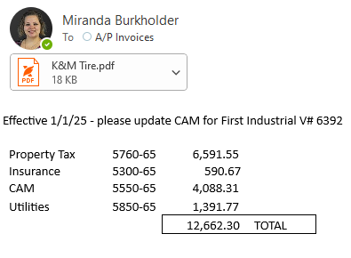

- RE Department Reviews CAM reconciliation & comparison before sending approval to Invoices@KMTire.com
  - This may require RE Department contacting the warehouse manager, comparing to previous reconciliations & or coordinating with the AP & NAB manager if additional questions arise.
  - Additionally, any updates to the Lease Comparison will be made by the RE Department. Spreadsheet is saved here F:\Langhals Companies\Lease – K&M warehouses
- AP Department Staff Updates Rent Document
  - After approval, support & GL breakdown is provided from Associate Director of RE & Facilities, AP Department Staff will update the rent document for the property by adding the effective date and the new amount.
F:\Accounts Payable\Shared\Forms\Recurring Entries\Group 1 - Monthly
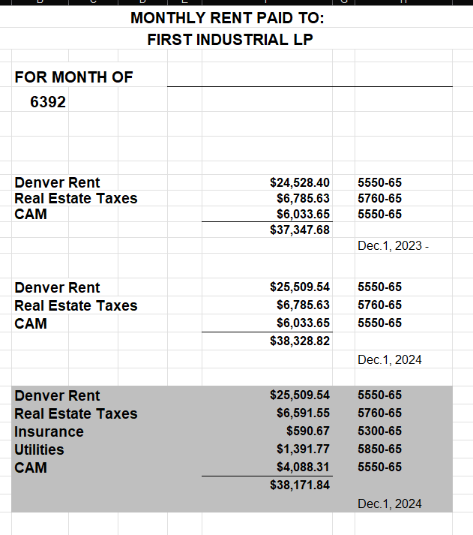

Conclusion

The purpose of this Standard Operations Procedure binder is two-fold. To provide new hire’s with a map to success in their new position here at K&M Tire Inc. By referencing to your Accounting SOP Manual you are already using K&M Tire’s Value #4 “Commit to the pursuit of perfection.” Perfection is our goal as we work to exceed expectations in all of our buisiness and in relationships with customers, suppliers and employees. While perfection is unattainable, we strive for continous improvement in all we do, getting better every day.
The second purpose is to have a reference tool for all employees, whether newly hired or seasonal, to consistently and correctly perform these tasks.

Appendix A: Miscellaneous
Add links here

Appendix B: Supportive Department Summaries
How we can help at the field level?

Instructions: Provide a list of acronyms and associated literal translations used within the document. List the acronyms in alphabetical order using a tabular format as depicted below.

Table 1 - Acronyms
Acronym | Literal Translation
<Acronym> | <Literal Translation>

Appendix C: Glossary
Instructions: Provide clear and concise definitions for terms used in this document that may be unfamiliar to readers of the document. Terms are to be listed in alphabetical order.
Table 2 - Glossary
Term | Acronym | Definition
Appendix D: Referenced Documents

Table 3 - Referenced Documents
Document Name | Document Location and/or URL | Issuance Date
Credit Card Request Form. Pg. 9 | F:\Accounts Payable\Public\Concur & Company Credit Cards
Appendix E: Approvals
The undersigned acknowledge that they have reviewed the User Manual and agree with the information presented within this document. Changes to this User Manual will be coordinated with, and approved by, the undersigned, or their designated representatives.
Instructions: List the individuals whose signatures are desired. Examples of such individuals are Business Owner, Project Manager (if identified), and any appropriate stakeholders. Add additional lines for signature as necessary.
Table 4 - Approvals
Document Approved By | Date Approved
Name: <Name>, <Job Title> - <Company> | Date
Name: <Name>, <Job Title> - <Company> | Date
Name: <Name>, <Job Title> - <Company> | Date
Name: <Name>, <Job Title> - <Company> | Date
Appendix H: Revision History Tracking
The following table records information regarding changes made to the Operations Binder.
Table 5 - Revision History Tracking
Version Number | Date | Author/Owner | Description of Change
 | 12/15/2022 | Angie Prichard | Updated Sections: 4.4.2 & 4.6.1
 | 1/4/2023 | Shaina Johnson | Update 4.10-4.13
 | 3/24/23 | Kayla Perrine | Updated Over/Shorts
 | 3/28/23 | Kayla Perrine | Updated Section 4.3
 | 12/29/2023 | Kayla | Updated 4.3.3
 | 4/30/2024 | Shaina Johnson | Add Membership Requests as 4.4.11.
 | 12/13/2024 | Shaina Johnson | Update 4.1.2 Issuing New Corporate cc’s to Employees
 | 02/12/2025 | Barb Suever | Added 4.9.11 AP Document Retention
 | 02/25/2025 | Barb Suever | Added 4.6.5 Check Run Timeframes
 | 5/15/2025 | Angie Prichard | Updated 4.6.11 Manual Blank Check
 | 6/11/2025 | Angie Prichard | Updated 4.9.8 Cardholder List Audit & First Financial eZ Card Access
 | 6/11/2025 | Angie Prichard | Added Section new 4.1.3 Concur User Setup
 | 6/12/2025 | Shaina Johnson | Update Section 4.9.1 MaddenCo AP Update
 | 6/13/2025 | Shaina Johnson | Update Section 4.8.1 Fiscal Year End
 | 7/31/2025 | Angie Prichard | Updated Section 4.4.9 United Way
 | 7/31/2025 | Angie Prichard | Updated Section 4.6.9 First Financial Online Payment
 | 7/31/2025 | Angie Prichard | Updated Section 4.1.2 Issuing New Credit Cards to Employees
 | 7/31/2025 | Angie Prichard | Replaced Section 4.3.7 Mighty Tire Invoice & Receivers
 | 7/31/2025 | Angie Prichard | Removed Section 4.13 & replaced it with Mighty Tire billing
 | 7/31/2025 | Angie Prichard | Updated Section 4.9.9 Credit Applications for Vendors
 | 7/31/2025 | Angie Prichard | Removed Section 4.6.13 Comcast
 | 7/31/2025 | Angie Prichard | Updated Section 4.6.6 File Paid Invoices
 | 7/31/2025 | Angie Prichard | Removed Section 4.9.7 Same Day Closed Invoice Voiding
 | 10/24/2025 | Jody Keller | Updated 4.10.1 Concur (letter f.)
 | 10/28/2025 | Kayla Perrine | Updated 4.9.9
 | 10/29/2025 | Kayla Perrine | Added 4 14 External CAM Reconciliations
 | 10/30/2025 | Kayla Perrine | Updated 4.9.5

